The Human Body
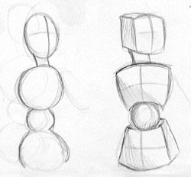 | When doing the figure, it is useful to sketch in a quick "dummy" so that you can get the basic proportions and pose, without having to spend a lot of time on it. If the pose or the drawing doesn't work out, then you havn't put loads of effort into the drawing and you can try again without regrets.  The dummy on the left is done with bubbles. I do not recommend this method because it is difficult to tell which way the bubbles face, and they really do not define the head, upperbody, and hips well. The dummy on the right uses boxes. Boxes allow you to see how the figure is bending because you can see the front, back, sides, top, and bottom.

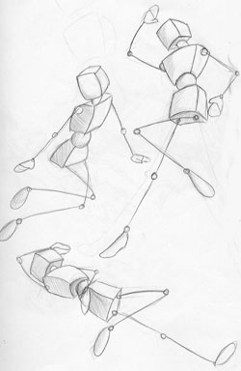 | Pose your figure however you want. The boxes will give you a good idea of how the final drawing will look.  Even though the figures here are simple, you can tell exactly how they are posed, and you have a good idea of what they're doing.  Draw your box figures until you find a composition that really appeals to you. Once you find a composition that you like, it's time to take that doodle to the next stage!

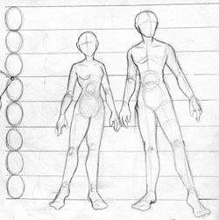 | The human figure is anywhere between 6-8 heads tall, depending on the individual.  The shoulders are 1 1/2 - 2 heads wide.  The torso and head are as long as the legs.  The hands fall halfway down the thighs.

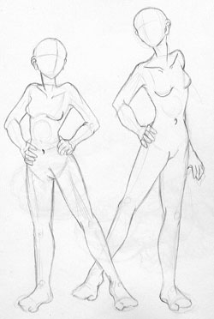 | Figures come in all shapes and sizes. Taller people will typically have longer legs and bigger feet.  The thigh and calf of a leg are equal in lenth, but not in thickness. The calf of a female will have a shapely curve.  The upper and lower arm are also equal in length, but not in thickness.  When standing still, a person will put one leg under their center of gravity and let the majority of their weight fall on that leg. It is very rare to see a person standing still resting the weight of their body equally upon both of their legs.

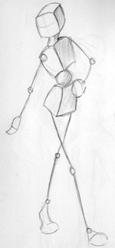 | Here is an example of a quick dummy that I am going to take through the steps to a more finished drawing. I get my basic pose at this stage. You will want to draw this in VERY lightly so that it is easy to go on top with more detail later. I drew this dark so that it could be seen for the tutorial.

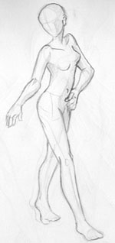 | I then go back in and fill out the figure. The box-like head becomes oval shaped, but bulges out in the back to allow room for the skull. Arms and legs are filled out, with the upper parts being thicker and more muscular then the lower parts. The torso keeps the bend where the connecting ball was in my dummy, but I allow the organic lines of the human torso to override the boxes, but I still keep the general direction the boxes were facing.

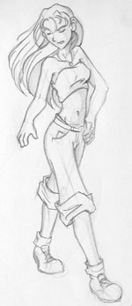 | NOW it's finally time to worry about the facial features and clothing. Because I had a good sketch, the final drawing looks smooth and natural instead of the awkward angles drawing it all-at-once will often give.

The Basic Head
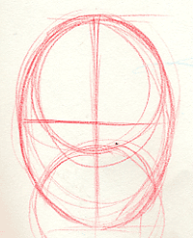 | Please note that this tutorial covers only the BARE BASICS on the human head. Every head is different, and the one shown here is extremely simplified and generic. It should still give you a good start to base your proportions off of. This is also not a generic anime head, more of a cross between American comics and realisl hence the eyes are not uber large, nor is the chin pointing, and nose and mouth small. I may do an anime style head tutorial in the future, but for now this gives you the basic idea of how to do a general head.  First start with an oval. The oval should be able to hold roughly one and a half circles vertically. Split the head into 4 equal quarters for a frontal view.  You're going to fill in the basic proportions of where the facial features will go. The eyes will fall right on the center line. There should be one eye width between the two of them, and a around 1/2 eyewidth to the edge of the face.

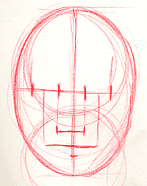 | The nose will fall 1 and 1/2 eye widths from the eyeline. The edges of the nose will be as far out as the inner edge of the eyes.  The mouth will be half an eyewidth down from the nose. The edges of the mouth will reach go out as far as the center of each eye (if you were to draw a line down).  Now it's time to fill in the last of the measurements. Your eyebrow line will be 1/2 eye width above the centerline.

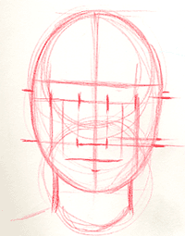 | The ears will occur between the nose and the eyeline.  The neck fills out to the outer edge of each eye (if you were to draw a line down).

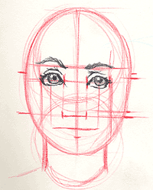 | Since I've got my basic measurements in place I'm now going to fill in the facial features with specific details so that it looks like the head I want it to. I generally start with the eyes, being careful to stay within my guides.

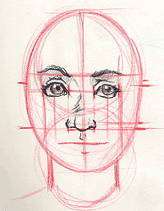 | I then follow with the nose. Since it is a head on view without a strong light source, there is not a huge line going down the center. Concentrate mainly on the shape of the bottom of the nose.

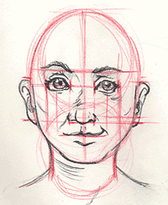 | Then place your mouth, facial shape, and ears within your guides. Please note that different people will have different facial features!

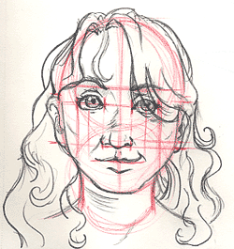 | Add your hair in last. Make sure that you don't place your hairline down to far. People do have foreheads, but they are overlooked because they are "blank".

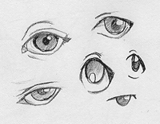 | Eyes can come in all shapes and sizes. Feel free to expiriment with style so that you aren't tied into something you don't want to be. Here are some ideas. The way in which the eyebrow is placed is the most important indicator of emotion.

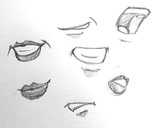 | The mouth is the second most important indicator of emotion. Practice drawing it open, closed, and in different expressions.

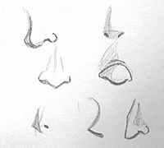 | Noses can seem unimportant, but they help to make a person look unique. There are many different ways to approach this.

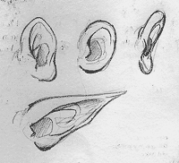 | Ears are what I consider to be the most generic facial feature. Here are some variations. (sorry I couldn't come up with more, there's really not much I can do!) Remember to include the natural curves and twists present within the ear to give it a sense of realism.

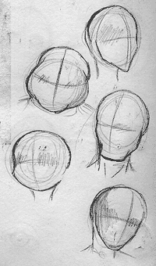 | A few basic ideas for head shapes. Every head is unique, so don't limit yourself!

Hair Basics
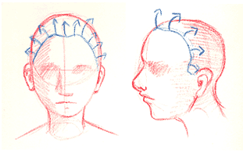 | This tutorial covers how to create and detail in hair styles by starting with shapes. A tutorial for hair in movement and complicated hair styles may be added in the future, but these should be enough to give you a good start.  The first thing that you should remember when you begin to create the hair is that hair grows out of the scalp along the hairline in a fanning out motion. The hairline can recede with older men, but for most women and young men, it falls along the line shown in this dummy.

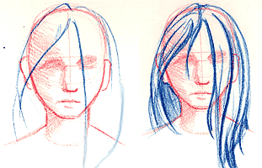 | The first style I'm going to try is a long haired style that covers the face partially. I start out with the basic shapes and get those looking correct before I go in with hair detail.

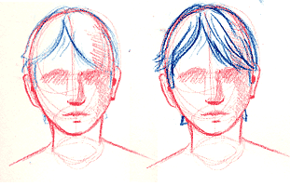 | I add chunks and strands that grow out along the motion of the shape and in the motion of the hairline. This shorter style also follows the same basic principle. Note how the hair falls down into two halves. Most hairstyles have a line like this, commonly in the center, that splits the hair into two sections.

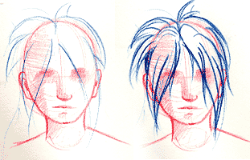 | Here's some gravity defying anime hair. Note that as I detail in the chunks I start where the hair grows out of the scalp, and then go along the motion of the shape.

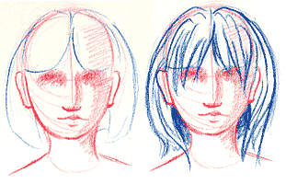 | Chunky bangs. Once again, the same basic forumla still applies.

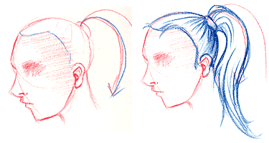 | Hair that is pulled back will pull from the scalp to the point where it bunches up in a single sweeping motion. From there, it will branch out and fall according to gravity in a pony tail or other such hair style. This dummy does not have any bangs, but bangs or other accents can be added.

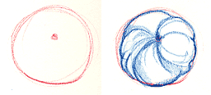 | Hair styles are complicated because the hair is pulled along unnatural paths into the desired style. Here is an example of a bun. There is a tie in the back and the hair branches out from the edges and pulls into the center. Complicated hair style can be confusing, so don't be afriad to use photo refrence if you're unsure of yourself.

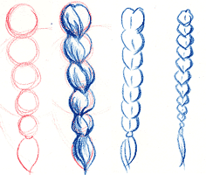 | A braid is another complicated hair style that flows along unnatural lines. Here are some cheats to make a braid-like hairstyle without having to weave your lines together. The basic formula is shown in red and you can then chunk out the shapes however suits you.

Basic Hands
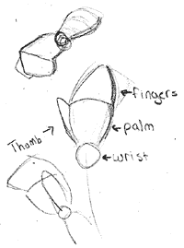 | Hands are as expressive a part of the body as the face. However, like the face, they are complicated and difficult to get looking accurate. Here are some basic ways to position your hands and to keep them in proportion.  When you are sketching in your figure, you do not have to worry about all of the detail in the hand and fingers right away. Break down the hand into simple shapes and lay in your drawing. Once you have everything positioned to suit your fancy you can begin creating the hand.

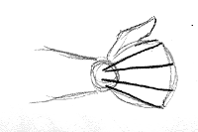 | Fingers branch out in a radius from the wrist. By spacing 4 lines evenly, you can figure out where the fingers will basically pop out of the palm.

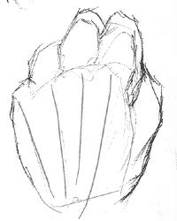 | I use my own hand for refrence a lot. As you can see, the shapes are very general, but by looking at my own hand and by using loose basic shapes, my drawing is coming together so you can recognize a fist.

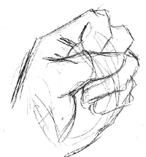 | Here's another quicky that I did with my hand as a refrence. Please note that your thumb only has 2 places where it can bend, while your fingers have 3 (these are counting the palm connection).

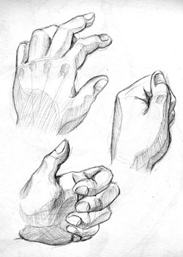 | Once you have your sketch drawn in, you can finish your hands by adding shading. Look at your own hand and you'll notice wrinkles, shadows, nails, and other fine details that you can fill in. Cartoons do not need hands that look this detailed, but if you want to go for realism, then every detail helps!

Inking Your Drawing
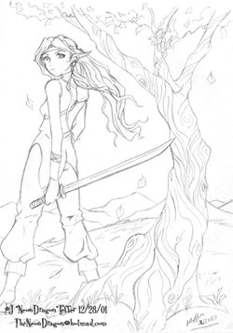 | When I color something in Photoshop, most of the time I ink it on paper first. Inking not only gives you a crisp line, but it can also give you a more dynamic piece of line value is used to give your drawing weight.  Any good inking starts with an equally good drawing. Sketch out your composition and put in as much detail as possible beforehand. When you drawing looks "finished" it is time to begin the inking process.  Please note that drawings can be colored in just about any medium without inking them. Inking will give it a cleaner look, while pencil will tend toward a sketchy, soft look.

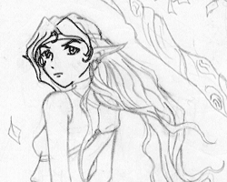 | Get a thin liquid pen. (gel, pilot, whatever is cheap and floats your boat) Slowly, slowly start inking your drawing by tracing over your lines. Make smooth strokes and continue them till the end of the line. This will help you avoid jagged art.  Microns and rapidographs make excellent inking pens and will tend to bleed less then brands like sharpie.

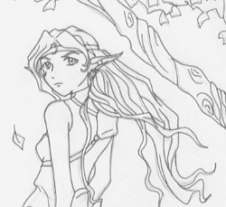 | Continue inking until your whole piece has been traced over in one even line quality.

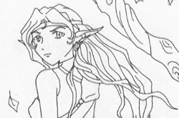 | Get an eraser that will not leave residue behind. White soft rubber erasers tend to work best. Being careful not to wrinkle or tear your drawing, erase all of the pencil lines. This will make your inking look a bit empty, but fear not, there is still work to be done!  (yeah, I can tell you're soooooooooooooo excited that you get to spend more time on this)

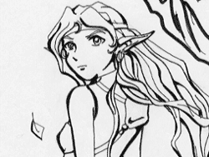 | Line value is the key to a good inking. Thicker lines can be used to show an area in shadow, or an area in the foreground. Notice how the strands of hair in the front have more value. This is because detail diminishes with distance. Things in the foreground need to stand out! Once you finish adding thickness to key lines you are all ready to color your image however your heart desires.

Coloring with Markers
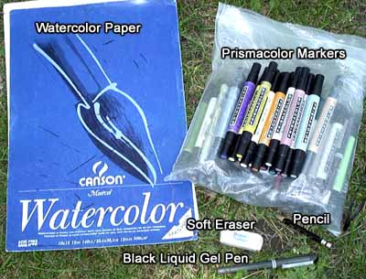 | This tutorial explains how some of the images in Dragon Shadows were colored with markers. The way that I color with markers is to lay down flat colors and keep blending to a minimum. There are other methods out there that will give you a completely different look with the same exact materials.  Pencil & Eraser - A pencil and a soft eraser for making the drawing itself. Nothing special.  Black Liquid Gel Pen - I use a gel pen for my inkings because the liquid flow keeps an even line and they are cheaper then micron pens.  Watercolor Paper - I use watercolor paper because with the way that I color, I want the ink staying put and not blending or moving around on the surface. Watercolor paper sucks the ink right up!  Prismacolor Markers - A selection of neutral (not bright) prismacolor markers. These are pretty expensive (about $2-$3 a pop!). If you don't own any and want to get a select few to practive with, I'd recommend getting a set of greys (warm, french or cool). You'll be able to complete finished looking b&w images with these markers and you won't need to buy a different color for every part. The greys are also a great place to start expanding from if you want your collection to get bigger.

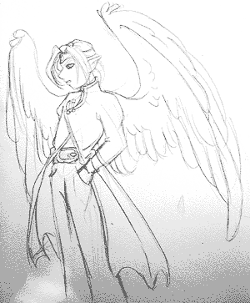 | First sketch in your image with pencil. Keep your lines light so that when you ink it, you'll be able to erase all of your pencil marks without tearing up your paper.

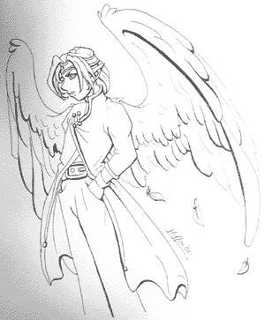 | Once your sketch is completed, ink with your pen. Line value (varying the width of your lines) will add depth to your image. Remember not to throw value everywhere... put it in stategic places!

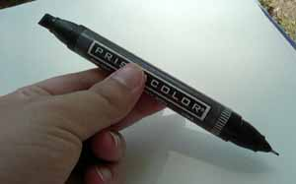 | Here is your basic prismacolor marker. Note that it has 2 tips. If you're just beginning, I know that you're going to be tempted to use the little tip for everything. DON'T! Using the little tip on medium or large areas will leave streaks and you will not have a nice flat color. You'll also wear out the little end's tip. Instead, use the large end. Practice using it to cover large areas, or using it on it's side to give you a thin to medium line. The big tip can color in most anything. I even use it on most small areas simply because I'm too lazy to uncap the little end!

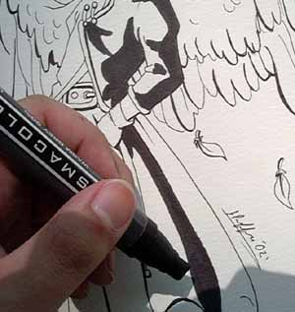 | I'm going to start by filling in the shadows in the coat and in the pants. There is no "trick" to doing this. You have to know where you want your shadows to go. If you're unsure, in pencil, lightly sketch in areas first and then follow with the marker. When using the marker, remember to keep the marker moving. Don't let an edge that you've put down dry for too long, otherwise your "flat" color area will have streaks.

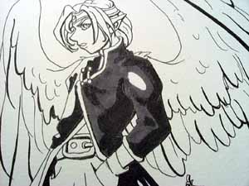 | I now move a couple of shades lighter and fill in the midtones. I leave any areas that I'll want lightly black. I can't take color away, but I can always add it.

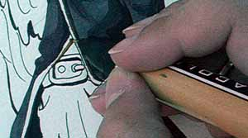 | The gold trim on the coat is a place where I'll want to use the small tip. using the large tip on such a small area would probably end up leaving a lot of ink outside of the lines.

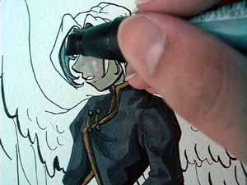 | Turn the marker to get into small areas. Remember to keep that marker moving if you want to avoid streaks!

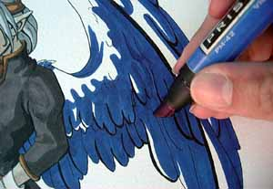 | The wings follow the same basic pattern as the rest of the image. I start with the shadows and work my way up.

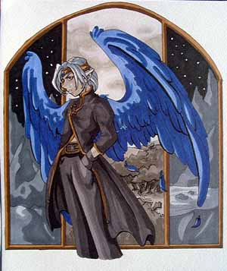 | The finished piece. I added in a border using a ruler and a pen. When you are finished with your work you do not need to spray it. The alcohaul-based markers will not lift off the watercolor paper :)

The Bare Bones of Watercolor
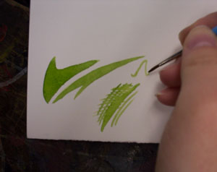 | Watercolor can be used in a variety of approaches. It is a translucent medium that can be built up, but is difficult to erase. This tutorial covers the most basic basics. If you find that you like watercolor, please, please, please get a book out from the library. There's some really great ones out there written by people far more qualified then I.  Before we start I'm going to show you two approaches to watercolor that are useful. The first is wet on dry. Making sure that the paper is completely dry, I add wet paint. The paint will not bleed out of the area where I paint. This is also good for line work and details.

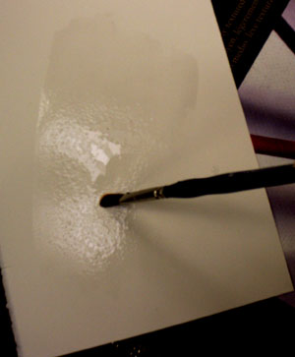 | The next technique is wet on wet. This is good for blended colors, sky, and flowing things. To begin, wet the area where you would like the color to be. The color will not go beyond where you have put water (how convienient!)

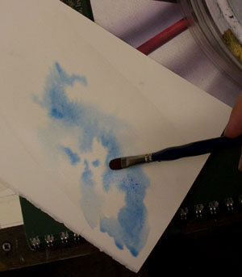 | Then blot, drip, smudge, and paint on whatever colors you like. They will blend and bleed together with ease. You can let it flow out naturally or let gravity do it's work by tipping the page. You can also blow paint using a straw.

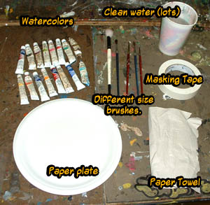 | Before you begin you'll need to gather and set up your materials. Here's what you'll need:  Watercolor paints. (tube or dried sets are both fine).  Several different sizes of brush. You're set if you've got a detail, small round, medium flat, and large wash brush.  A paper plate or pallette.  Masking Tape.  A water cup full of clean water.  A paper towel, kleenex... something to blot up a mistake!

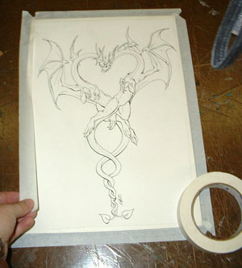 | I'm working on some pretty cheap watercolor paper. This particular piece is 140lb cotton. Once your drawing is complete you'll need to stretch the paper so that it doesn't bend and warp with the water.  Tape down all the edges of the paper as tightly as possible. Take your large wash brush and water down the entire sheet of paper. Let it dry completly and it then be stretched taunt. This step can take 1 hour or more if you do not use a blow dryer. If you skip it, your paper may warp when you start to paint.

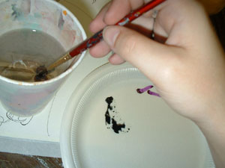 | I squeeze out some of the colors that I'd like to use and start adding water to the paint. I drag a lot of water onto the paper plate because I want the color to be lighter. Since watercolors are translucent, the more water you add, the lighter the color.

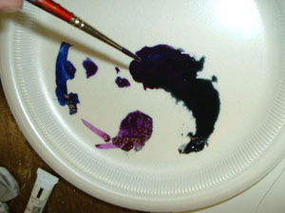 | I then mix my purple and paines gray together to get the exact color that I'd like. Don't be afraid to mix your paints or you will end up with generic colors. Mixing colors is risky if you don't know what you're doing because it's easy to get muddy looking watercolors if you're not careful.

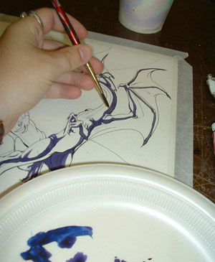 | I personally like to block my color in in cartoon like manner because that's my personal favorite style. To do this, I start dark and work lighter. If you would like softly shaded watercolor, you'll need to wet the entire area and keep it wet while you slowly shade and blend the color. (soft blended color is best achieved working wet on wet)

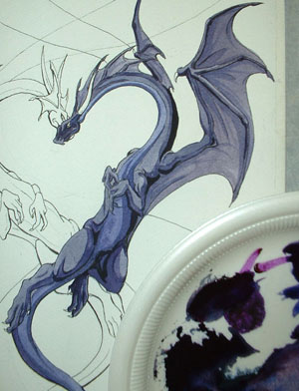 | The entire dragon was done using the same color with different amounts of water added to it for darker and lighter color. To a degree this is nice because it looks uniform, but being uniform makes it flat as well. I happen to like flat, cartoon-like things, but if you would like more depth go for warmer and cooler versions of your color.  (note that this technique is wet on dry. The paper was completely dry and the color I was applying was wet. Each time I added a new shade a wait for things to dry completely)

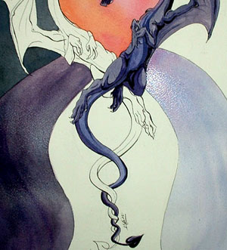 | By wetting down an area and then adding color to it you can achieve smooth, blended color. This is known as wet on wet.  The rest of the image can be completed with the same techniques used in each area. Happy painting! For some great books on watercolor, check out the "Northlight" line at any local bookstore.

Oekaki Painter
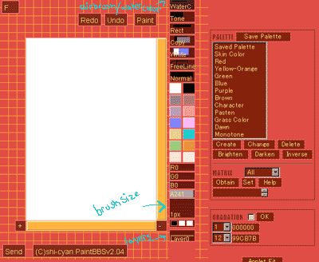 | NeonDragonArt.com finally got it's own set of Oekaki Boards. I've noticed that a lot of people are unclear on how this little program works, what the tools do, and where they are located. This tutorial covers most of the basic tools, and shows you a little bit of how to cel shade (my preferred oekaki method). Feel free to oekaki in a way that fits your style. I hope that this tutorial gives you a little bit of help with the basics of the program. Note that this tutorial is for the Painter option in oekaki. You a choice of 3 programs to use when using the boards.  Okay, here is your basic oekaki setup. I'm using "shi oekaki" the most current version. To start off with I'm going to sketch out what I'd basically like to draw very loosely.  Making sure that I'm on layer 0, I click on the top box in the right colum until it says watercolor. The watercolor brush is semi transparent and doesn't pixelate like a solid brush will.

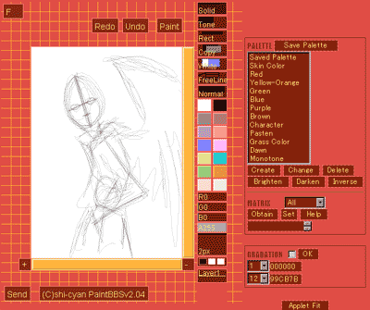 | I then rough out the basic pose and shapes that I want to use. I don't have to be exact, because I'm going to make my pricise lines later.

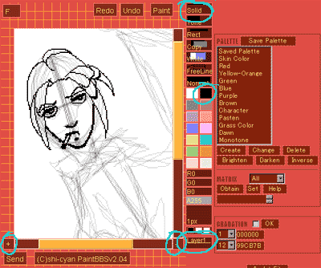 | If you click on the lower right box that says "layer 0", it will change to layer 1. Layer 1 is on top of layer 0 so it's ideal to put your final lines on this layer (that way you can color underneath them later without worrying about messing up your linework!).  To "ink" the image I use a solid brush at 1-2 pixels big. You can zoom in to do finer details by using the + and - buttons located in the lower corners of the drawing area.

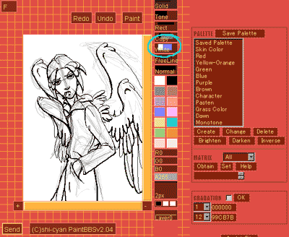 | I've inked my entire image. I want all of my solid lines on layer 0 to be very clean. If you make a mistake, use the eraser tool (circled on the example to the left) to clean up your mess. DO NOT use white paint! If you use white paint, when you color under it you won't be able to see through because it is not transparent!

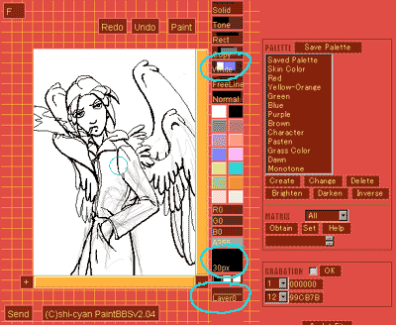 | Making sure that I am back on layer 0 -the one with my sketchy lines- I get the eraser tool and drag the brush size to the maxium, 30. I then use it to erase out all of my sketchy lines so that I am left with a blank layer below and clean linework on top.

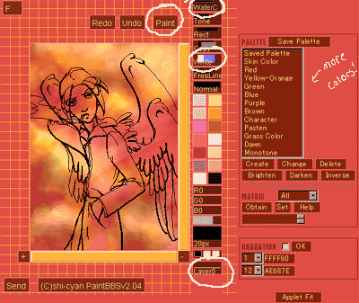 | If you'd like a background it's best to do it first so that you don't have to worry about going into the lines or messy cleanup. To do this cloud background I used the paint option to fill layer 0 with red paint. I then used the watercolor tool to make airbrush-like clouds in the background. I used the brush slider to ajust the size of my brush when doing this.  Complete your background before moving onto color to save time. You can do it backwards if you like, but I find that it becomes to timeconsuming to do it that way.

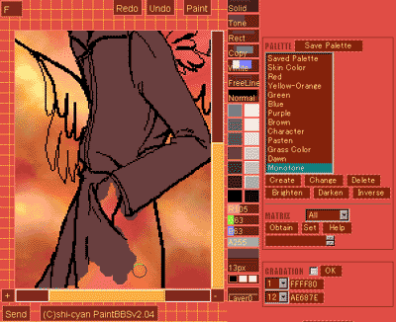 | Staying on layer 0 I use a solid brush to fill in my trenchcoat.  Since I'm going to be painting over my wings and skin, it's ok if I go out of the lines into those areas. Since I want to keep my background, I stay in the lines very carefull around edges where the trenchcoat meets the sky.

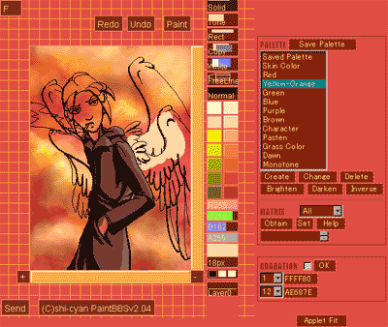 | I shade in my trenchcoat using smaller solid brushes and then move onto the wings. Since I want to keep the work I've done on my trenchcoat and sky, I make sure that I'm very careful when painting near those areas.

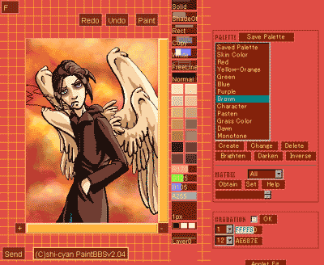 | Okay, all of my solid colors are done! Time to do that smoke!

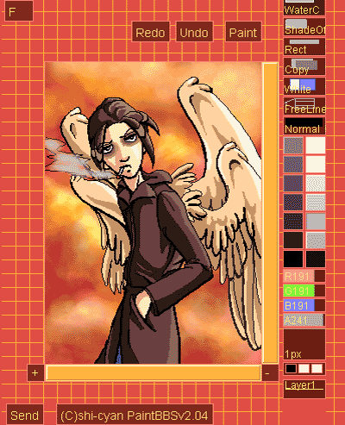 | To do transparent smoke I went back to layer 1 and used the watercolor brush to color the area. The watercolor brush is naturally transparent, so it gave me the effect that I wanted.  You don't have to follow this tutorial rule-for-rule, but maybe it was helpful for giving you a start!

Using Oekaki BBS
NeonDragonArt.com finally got it's own set of Oekaki Boards. At one point, NDA used the oekaki potato program. This program used oekaki bbs as it's main paint option. NDA doesn't use oekaki bbs anymore, but I figured that it couldn't hurt to leave the tutorial up for those who use this particular program on other websites. If you're interested in reading up on the drawing programs that NeonDragonArt's oekaki boards use, please see the paint bbs or shii bbs tutorials.
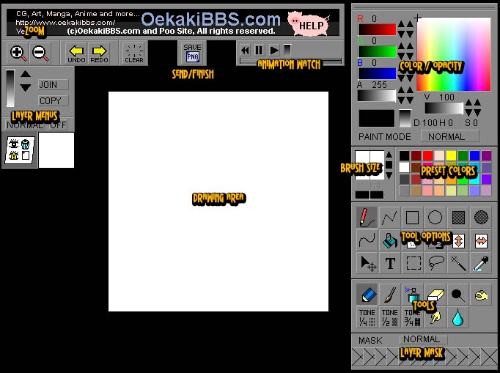
Oekaki BBS is much more complex than Paint BBS and gives you a lot of options to play around with. It's very much like a mini version of Photoshop. I'm going to give you a basic overview of what each of the labeled areas is, and what they do. We'll follow the explinations with a step by step example of how I used some of the tools to create a simple, finished picture.
Drawing Area - This is the active area where you're going to be able to do the drawing. Pretty self-explanitory, nothing fancy here.
Send/Finish - When you are finished drawing or ready to quit for the day, press the Save button to send your image. You can resume your image later if you choose to.
Animation Watch - The only time you'll need to use this little area is if you are resuming a picture to work on it some more. When you first try to resume your picture, you will be given a blank canvas. To pick up where you left off, you'll need to play your animation and the program will fill in the canvas as you left it. The nice part about this is if you don't want to resume at the last point, you can pause and pick up the drawing at any point in between. most people will want to pick up at the last place though.
Zoom - Zoom in and out of the canvas. It is useful to Zoom in if you are working on a high detail area so you can see things better.
Layer Menus - These menus will allow you to create and rearrange your layers. More info later in the tutorial.
Color/Opacity - This big menu box lets you choose your color, how dark you want it to be, and the transparency of your brush. There will be more info on how to work this little guy later on in the tutorial.
Brush Size - Pretty self explanitory. This box lets you make your brush larger or smaller by clicking the up and down arrows. A brush can be anywhere from 1 pixel to 40 pixels in diameter.
Preset Colors - If you're feeling lazy and don't want to use the big color menu to make your own colors, you can use the preset colors. That'a all that there is to that area.
Tools - The Basic Tools. You can have a hard edged pencil, a softer paintbrush, an even softer airbrush, an eraser, and more. These tools can be customized by using the tool options above.
Tool Options - After you've selected your tool, you can tell it how to behave using the tool options menu. It can operate as a paint bucket, a freehand line, a straight line, a tool, and much more. More info on this menu later on in the tutorial.
Layer Mask - Mask off areas so that you don't put color where you don't want to. For advanced users only.
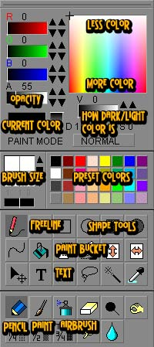 | Okay, time to break up all the little options on that right hand panel! It's a lot to look at, but don't be intimidated. These menus are what kinds of brushes, colors, and modes you are going to paint on your canvas in. Let's look at the most common tools to get you started!  Color Box - See that box with the rainbow fading in it? That's where you can create your own custom colors! The white colors near the top are not for how light your colors are going to be, but for how much saturation it has (in other words, how red is the red?) The colors closest to the top are going to have the least amount of "pigment"/brightness to them. The colors near the bottom are going to be the most vibrant. First select what color you want and you can darken and lighten it using the slide bar underneath. You can see the current color in the box to the left. The opacity control will make your brush transparent. The lower you go, the more transparent it will be. If it is slid all the way to the right, it will be completely opaque (you can't see through it).  Tools - Let's go over the basic tools. Pencil creates a paint brush with a hard edge. Paint brush has a slightly softer edge, and airbrush is very fuzzy! The eraser tool actually erases whereas white paint just covers. The black ball is the dodge tool which will make your colors lighter, and the hand next to it is the burn tool which will make your colors darker (these will let you shade quickly). The hand with the finger on the lower level is the smudge tool and you can smudge your colors together for easy blending. The water drop will also blend paint together, but not in a direction. The tones are for if you want to use halftones instead of paint to shade with.

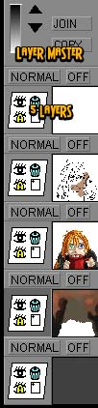 | You can paint all on one layer, but using layers is a very handy tool. I suggest getting aquainted with them to save yourself lots of headaches. What is layering? Well, it's putting one set of colors on top of another on top of another. In this case I have a solid background color at the bottom and some more background information on top of that. On top of THAT, I placed character color and on top of THAT I placed linework. The topmost layer was for smoke and highlights. Because of the layering, I did not have to worry about taking my background right up to the edge of the chararcter, because I could just put everything BEHIND it. Because of layering, I could put my linework on top and not worry about going over it with color. Layers are a beautiful thing.  Layers - Each layer has it's own little set of controls to the left, and a preview of what's on each layer to the right. The eye will let you see the layer or hide it. The trash can will let you delete it. The +page will let you create a new layer on top. I'm really not sure what the eye with a T in it does, but I assume it hides/shows text. To select which layer you are working on, click it. It will appear a slightly darker gray. In this case, the 4th layer is the one being worked on because it is slightly darker.  Layer Master - This little guy lets you move your layers up and down. To do this, select your layer (which will make it a darker gray). Click up or down on the arrows and your layer will move up or down in the layer order. If you hold down shift, you can select two layers and by clicking "join", combine them into one. Copy will let you make a copy of whatever layer you have selected (useful for if you want to try something new, but don't want to ruin your original. If things don't work out on the copy, you can always delete it).

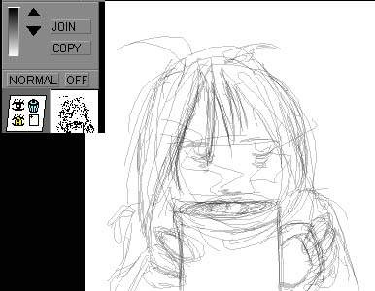 | Let's do a step-by-step drawing together using my favorite method. I like to start out and sketch a basic idea of what I want loosely on the canvas. It ends up looking pretty messy. To do this light pencil look, I used the pencil tool with a freeform line at a transparent setting (use the menus on the right to do this). The color I was drawing with was black, but since it is transparent, it appears gray. Note that at this point in time, I only have one layer.

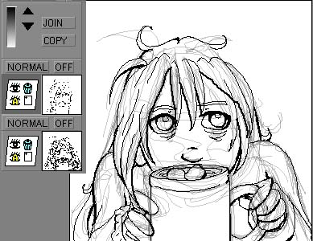 | I create a new layer on top to do my final line drawing with. Note that since I am working on the top layer, it's menu is a darker gray than the one below it. I take a completely opaque pencil and draw my lines exactly as I want them. When I finish, I will use the trash can on my sketch layer to delete it - I no longer need it.

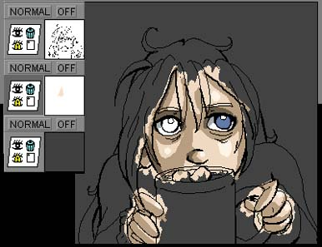 | I want to color my character in, but I don't want to have to worry about accidently running into a line and ruining my pretty drawing. I need a new layer! I create another layer using the +page button, but it is on top, and not below my linework! AghhH! Not to worry, all I need to do is use select the layer I want to color on and use the layer master's down arrow to move it down one space. I then place all my colors on that layer using my favorite tool for slackers, the pencil tool.

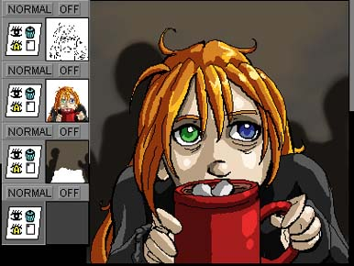 | Now I think I'm ready to do my background, but I don't want to have to paint all around my character ever-so-carefully... bleh... that takes too long! Instead, I'm going to make another layer and put it behind everything else. I can then paint in my background using a soft airbrush tool without worrying about going over my character.

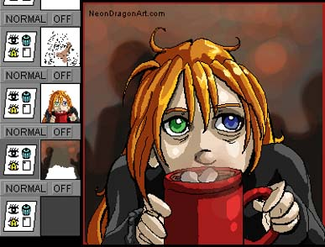 | Finally I create a layer on top of everything, even my linework, for my neondragonart.com text and some smoke for the hot cocoa. The smoke was done using a transparent airbrush. I think I'm done! Time to save and share my oekaki masterpiece with the world!

Shii Chan Pro
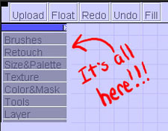 | Shii Chan Pro is an an oekaki program available online here on NeonDragonArt.com. It's got a bit more options then the paint bbs oekaki. This tutorial will help get you familiar with the pen and watercolor tools, the shii chan setup, and a basic method for creating and coloring a line art drawing.  When you open up the shii program there are not many options available. To access all of the menus and tools that shii has, you'll need to click on this box. Each bar opens up a different toolset.

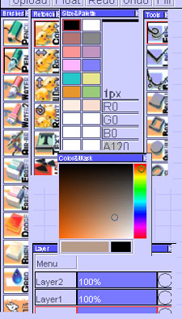 | After clicking everything open you can drag the menus around and arrange them however you prefer.

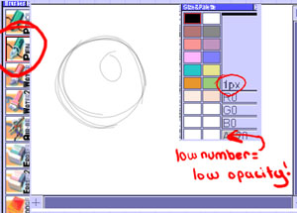 | To start with I like to get a light, loose sketch down. I used the pen tool at 1 pixel wide and a low opacity. You can control the transparency of your brush using the "A" slider. I then begin sketching on layer 0.

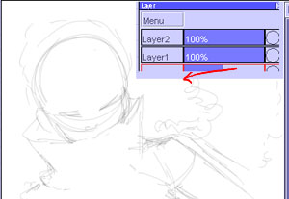 | Once my loose sketch is finished I turn down the opacity of layer 0 so that the lines become faint. This makes it easier to ink my final line drawing on top of it without getting confused. I will do my final inks on layer 2.

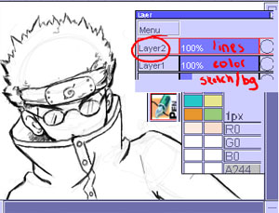 | Using a higher opaqueness (A slider is higher up!) I go over my lines and make them crisp. My final linework goes on layer 2, and my color will go underneath it on layer 1. The sketch layer (0) will eventually become a background.

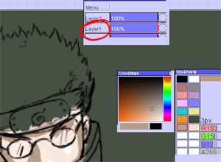 | Since I have finished with my sketch, I color over it with a background color. I then move to layer 1 and begin coloring in my drawing. The color/mask toolbar allows me to choose a very exact color! To go through the diffent hues, move the rainbow slider up or down. Then select the tint or shade of that hue that you would like to work with. I'm still using a pen tool to color, but my brush has been taken up to 3 pixels to make coloring easier. To resample a color you used previously, hold down "crtl" and click on the color you would like to sample so you can use it again.

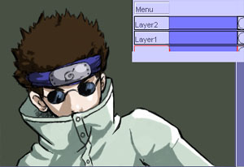 | After finishing the colors it's time to think about a background. Go back down to layer 0 and begin your work!

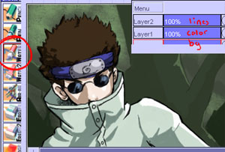 | Because I wanted a soft look for the background, I went with a watercolor brush for my tree texture. This gives me a very soft, transparent paint job that I can slowly build up.

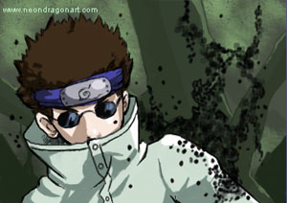 | Back up to the ink layer! (Layer 2) I gave Shino some bugs to play with. He is a bug ninja after all! Once my image is complete I hit "upload" and send it off! If I were to get tired in the middle and want to resume the image later, I would still hit upload, but at the final screen I would choose to do a save instead of a post. You can have one save at any given time to resume at a later date.

