Prepping A Pencil Sketch
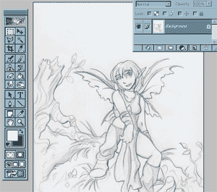 | So you've got a great sketch, and you like it just how it is... except it's really far too light to color. This tutorial explains how to darken and clean up your sketch in Photoshop.  Start by scanning your drawing into Photoshop. If you're planning on coloring the drawing after the clean-up, scan at 200dpi (dots per inch) or greater so that you are able to get in all the little details.

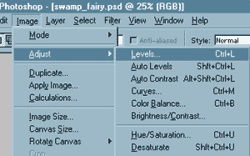 | Under the image menu, pull down the "Levels" option.

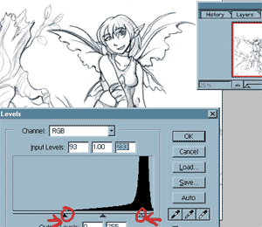 | Pulling the arrow on the right in will make your whites whiter, and pulling the arrow on the left will make your darks darker. Pull them in until you are satisfied with how the contrast looks. If you are unsure, pulling in until the top of each arc will usually give you a fairly balanced drawing.

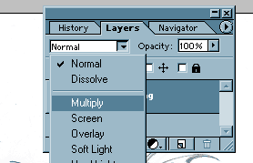 | If you are not going to be coloring, then you are ready to save. If you DO plan on coloring your image, pull up your layers menu. Set the dropdown box from normal to multiply. This will allow you to color underneath the sketch.

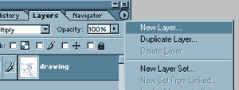 | Create a new layer for the color. If you try to color on the drawing layer itself you'll lose your lines and shading.

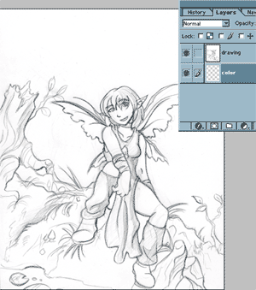 | Drag the color layer underneath your drawing layer. You are now ready to color your image! If you would like to see how this particular image was colored, check out the "Another approach to CG" tutorial.

A Build-Up Approach to Photoshop Coloring
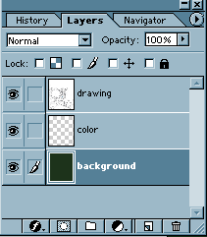 | There are many different approaches to coloring digitally. This one focuses on starting with a solid color, and building all the rest of the colors on top of it to give your painting a general color scheme. This tutorial is for Adobe Photoshop, although if you have another program that uses layers, you may have some luck with it.  Starting with a basic color and then painting on top of it is a great way to give your image a general feel and color scheme. It's also fun to try out if you're getting board coloring things the same old way.  To build up your painting on top of a solid color, you'll need your layers organized in this order. On top is your drawing layer. This contains the sketch or inking that you scanned in and want to color. Make sure that this layer's properties are set to "multiply". Underneath, you will have the color layer. This is the layer in which you will add additional color. On the very bottom, you will have the background color. I selected green because I want my picture to have a swampy feel to it.

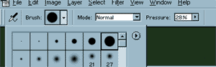 | I'm going to use a hard edged airbrush (not the paintbrush!) set at a flow of about 25%. The really soft brushes don't stay in the areas that I want as well as the hard edged ones, and the paintbrush is far to flat for building up color.

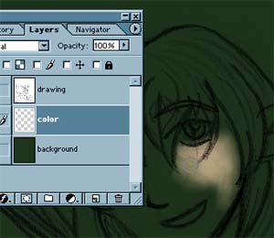 | I'm going to start by building up her skin. I chose a peach color; since this color is lighter then the green background, I'm working in reverse - putting the paint down where I want the hightlights, and letting the paper (the green) show though for the shadows. If you remember to work on the color layer instead of the background, it makes life easier because you can erase mistakes easier without taking off all of the green.

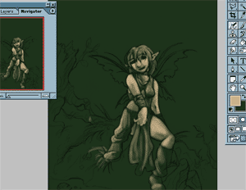 | I continue to use the same color throughtout the rest of the image. I do this because in the beginning, I'm still trying to keep the image unified in its color. The very last thing you're going to worry about is the true color of things. For now, concentrate on light and value.

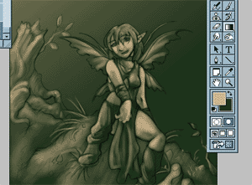 | I've worked the peach into just about all of the image.

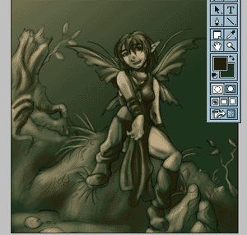 | I now move in with a darker brown. I work this into most of the image.

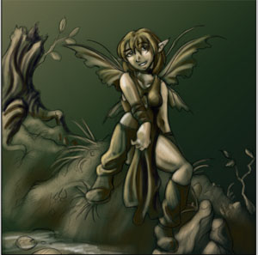 | My color scheme is pretty well established. I can now work in some gold. I'm only going to put it where there would be gold color. It's now up to you to work color into the rest of your image. Keep working with the airbrush and build up your color.

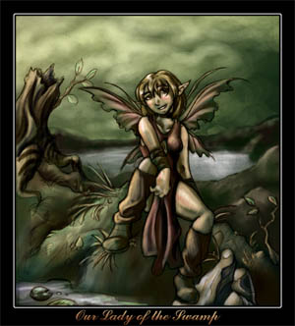 | The finished image. Note how even though I used a lot of colors, the peach and green really show through and make the image seem like it has a mood. This technique may be fun to give a try ^__^

Sparkles & Stars
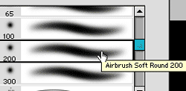 | One of the special effects that I get asked a lot about is my "magic sparkles" and stars. Here is a tutorial that gives the basic way to make a sparkle. This tutorial was created with Photoshop, but if you have other art programs with an airbrush tool you might have some luck with it.  The first step to making a glowing sparkle is to choose a wide, fluffy airbrush to create the outermost glow. The sparkle taht I am creating for this tutorial is VERY lage, so I'm choosing a 200 width brush.

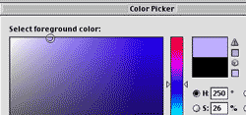 | I want for my sparkle to be mostly blue, so I select a hue that is along the top of the color chart, but that is not too close to white. Choose a high value hue for whatever color you decide to use.

 | I set the brush to operate at a low flow, or pressure. Something around 30% is usually good. I then click where I want for the sparkle to appear. I click just once, and I release immidiately so not too much paint is released.

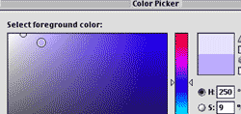 | To create the innner glow, I select a color that is brighter then my first, but is not pure white.

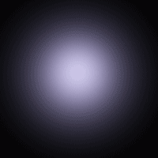 | I then select a smaller brush - 100 pixels, and I click in the center, just once. Note how the center is now much brighter, like something inside of it is radiating the light.

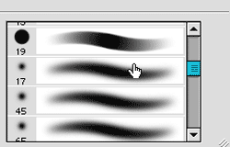 | Choose a very small brush. Your brush can be soft or hard edged, depending on how dominate you want the inner sparkle to be. A hard edged brush will give you a very crisp inner light.

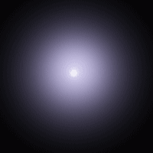 | Turn up the pressure or flow on your airbrush to 60% and click once in the center, holding down for about half a second. The sparkle is now complete! This sparkle is very large, and would be appropriate for a single ball of light in a magic spell. Stars will not have nearly so large of an outer glow, nor will they be as bright.

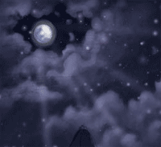 | I have filled my night's sky with stars. For doing multiple sparkles, it is best to do all of your outer glows at once "click, click, click!". Then do all of your inner glows, and finally the origin of the light. Doing it this way will save you lots of time switching between each color, brush, and pressure. Happy magic-making!

Photoshop Clouds
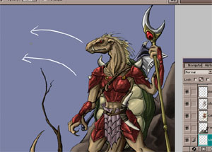 | Please note that this tutorial is for the program Photoshop. If you are using a different program you may have some luck with the same technique, but your menus and tools will likely be different.  Before you begin laying down color figure out what direction you would like your clouds to move in. In this particular picture I want them at a very slight diagonal to cross with the direction of the lizard warrior.

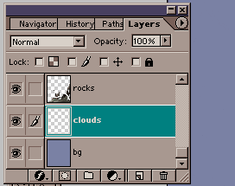 | So that it is easy to edit the clouds, I'm going to put them on their own layer just above the sky, but below all the rest of the foreground color.

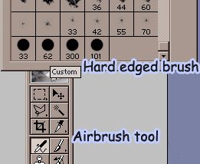 | I've found that a hard edged airbrush is the best way to create a fluffy texture. I've made my own size brushes by clicking "create new brush" in the brush menu and making a 300 pixel, a 100 pixel, and a 60 pixel hard edged brush.

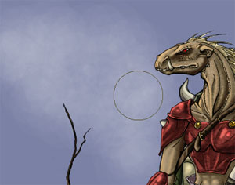 | I start by using the biggest brush I created, the 300 pixel brush. Using a 20% flow I make slow circles to create a light fluffieness in the background. It is from this abstract fluffiness that I will pull out cloud shapes. Since my sky is blue, I can pull out whitish clouds for better weather.

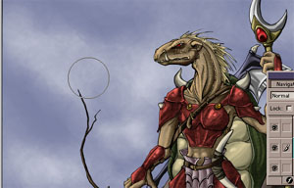 | Raise the flow on the large brush to 30% and make circles along the tops of the airbrush shapes or wherever the light source is located. To make your clouds convincing they'll need to be lit in some way.

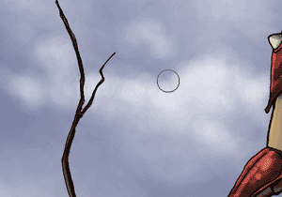 | Switch to a smaller brush and define the edges of your clouds by really laying the value on their. It is at this point where you will choose what kinds of clouds you want. I love my fluffy cotton candy clouds because they allow you to put a lot of interesting shapes into them.

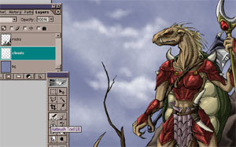 | Continue to heavily define the edges lit by light sources.

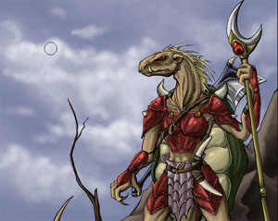 | Add more shape to the inside of the clouds so they are full and believable. If they are just fluff with really hard edges they won't work. I used my 100 pixel brush to do this because it is big enough that it doesn't streak, but small enough that I can be more exact with where I lay it.

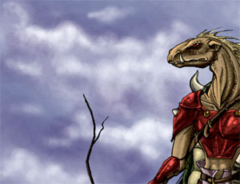 | It's very unlikely that clouds are just pure white, so work in some other colors. In this step I've added purple shadows to help define the lower portions of the clouds.

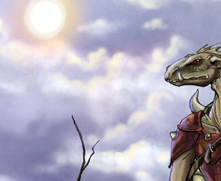 | Last, I finish off the image with my light source, the sun, and cast purple's opposite, yellow, as the warm light source. I crest each of the edges with this color to make everything come together. These cloud effects where made with nothing but 3 different size hard edged airbrushes. A little bit goes a long way!

ND's Spiffy Hard-Soft Coloring Trick
(For Adobe Photoshop)
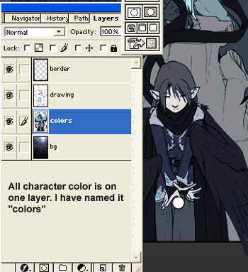 | This tutorial will show you how I got the hard and soft coloring that you can see in some of my more recent Dragon Shadows Images. This tutorial will work best for you if you have allready read and understood my previous Photoshop coloring tutorials ... or if you have a good knowledge of Photoshop on your own!  The trick of this type of coloring is that all of your flat colors must be on one layer.  Put your Photoshop Image together using a layer with your inks (drawing) on top of a layer of flat, simple colors on the characters and objects (colors). All of this can go on top of a background if you desire.

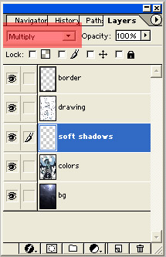 | Create a layer for your soft shadows just above your flat colors. Make sure that the blending mode is set to "Multiply". Multiply means that this layer will make everything below it darker.

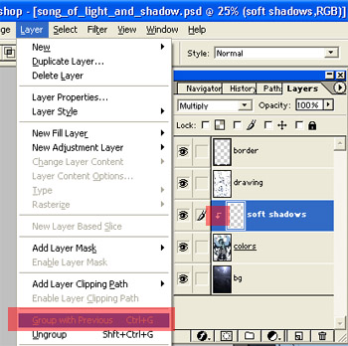 | Making sure that your "soft shadows" layer is highlighted, go under your layer menu up top and select the Group with Previous option.  This basically means that it will only affect the layer directly below it, and nothing else, thus it will only show up on things that have flat color on them. All of the transparent areas around the characters will remain so. The soft shadows layer has no power to affect them!

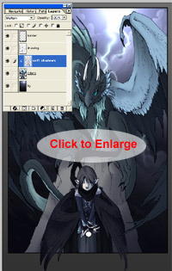 | Select a single color and run some very simple, very generic soft shadows across your image where you would desire. Use a big "fuzzy" airbrush to do this. Don't worry too much about detail. We'll be bringing that out with our hard edged solid shadows later on!  I've used a light blue on my image - However, it doesn't look that way! That's because of my "multiply" layer setting. It will only darken things below it, so even a light blue will show up as a darker shade of the color that it is sitting on top of. I don't have to worry too much about staying in the lines because my layer is grouped! These two tiny steps before all the shading will make things much easier and faster!

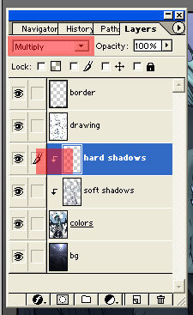 | It's time for the hard shadows. By "hard" I mean the solid, blocklike colors you see in cartoons and animation, rather then the soft, gradiated, "real life" type shadows.  Create a layer on top of your soft shadows layer. It's blend mode should be set to multiply, and you should repeat the layer menu "group with previous" option.

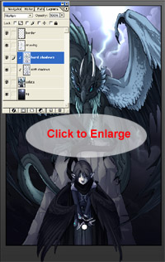 | Using a sharp edged paintbrush at 100% opacity, I start filling in my hard shadows. It will look like it's painting transparently because of the blend mode "multiply", and once again, it will only darken things below it, so it is safe to use a very light color to shade everything.  In this image, I used the SAME EXACT light blue to shade everything!  Can you handle... part 2???

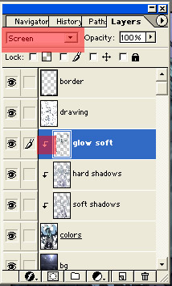 | Click to return to part 1  It is now time to add highlights! I am going to do this in much the same way that I approached the shadows. The important thing is that this time around, "Screen" should be your blend mode, not "Multiply".  Screen is a blend mode that makes everything below it lighter.  Once again, do the layer--- group with previous option that you did with soft and hard shadows. It will give you the happy little arrow icon.

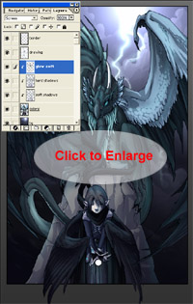 | I used a VERY dark bluegreen to highlight everything. Using a soft, fuzzy airbrush, I ran very, very basic highlights across my image.  The reason why I used a dark color is that it is less powerful then a light one. Since everything gets lightened automatically, a darker color makes this effect less harsh, while a light color that lightens via screen makes everything almost pure white (yuck!)

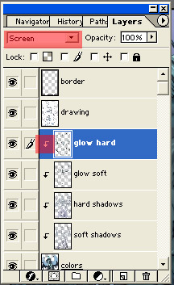 | It is finally time for the hard highlights! Create a layer above your soft glow that has a "Screen" Blend mode, and also has the happy "grouped with previous" arrow that we've grown so fond of!

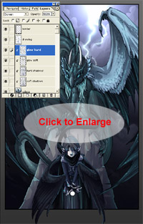 | Using a hard edged paintbrush, I chose a dark blue green to do all of my hard edged, animation-like highlights. As you can see, "screen" made my very dark green show up lighter across each color below it.

Here is the completed image. I hope that this tutorial was helpful for you! This is not a beginner's tutorial. If you have never colored with Photoshop before, I recommend my other two coloring tutorials here on the site.
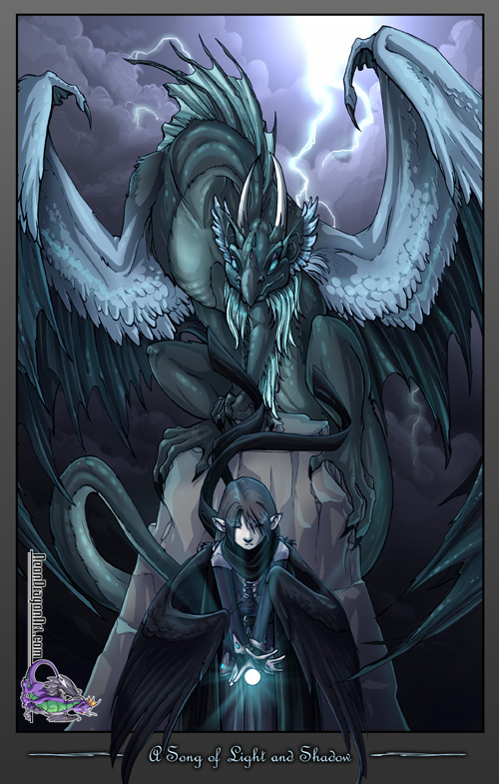

Soft Style Coloring
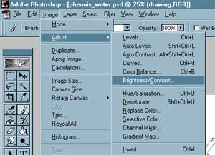 | Before you can start, you will need a drawing. It does not matter if the drawing is inked or is still a pencil sketch; both types will work for this style of coloring. For a crisp look you'll probably want to ink, for a softer, more artsy look you may way to just leave the pencil lines as are. Make sure that when you scan your drawing into the computer you scan at a higher resolution. (200-300 dpi is usually good)  Open up your sketch or inking in Photoshop. Under the image menu, select brightnesss and contrast.

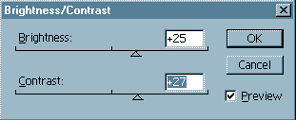 | Adjusting the brightness and contrast will get rid of extra "noise" in your picture. Turn the brightness and contrast up until you get a nice clean image. Be careful not to go too high, otherwise you will get pixelly edges.

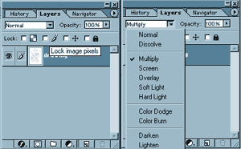 | Now that you have a nice looking image, go to the layers menu. If your layer is named background with a little lock icon next to it, double click on that layer. Rename it to "drawing" "outline" or whatever will help you remember that that layer is the drawing. Change the option box that says normal to say "multiply". This will allow you to color underneath your drawing.  Multiply is a function that says that the layer will only darken the things beneath it. Since white is the lightest color, these areas will not show up. Blacks and greys will be strengthened. Don't understand? Just try it and you'll start to get the concept.

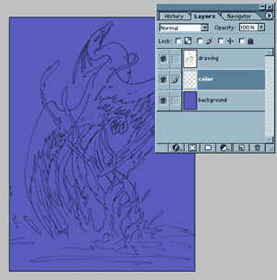 | Now I have created two new layers and have dragged them under the drawing. The second layer is blank and is called "color". The third layer is called "background." I have used the paint bucket to fill it with the main color of my background, and of my whole image.

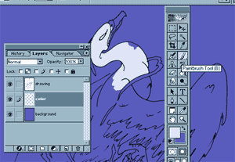 | Making sure that I am on the "color" layer, I use the paintbrush tool and start to color in my image. I color everything with flat colors. Make sure that you get all of the areas of the drawing with the color you want; a clean color layer is important. Shading will take place later.

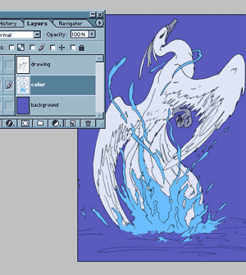 | I have now colored in all of the drawing using flat colors. I got into all the little crevices using smaller paintbrushes (not airbrushes). All of the colors are on the color layer.

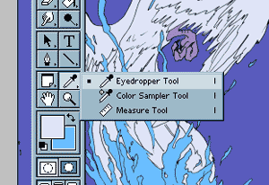 | Now it's time to prepare for the shading. Create a new layer above "color" but below "drawing" and call it "shadow." Use the eyedropper tool and sample the color that you would like to start shading. You can sample the color by clicking your mouse on the color while using the eyedropper tool; if you've done it right, the color should appear as being the foreground color in your tool bar (the one on top)

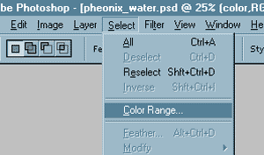 | ...now click on select/color range... Prepare yourself to be astounded.

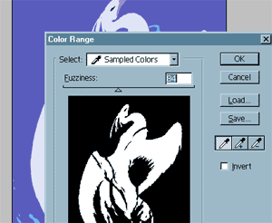 | Now a box will pop up that will highlight all areas of your picture that have that color. Adjust the slider until you have a nice clean selection. NO extra grey or jagged edges should show! Hit ok.

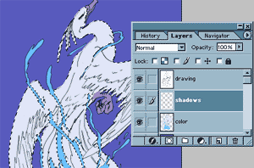 | Zom! All of that color is now selected. You can shade without going out of the lines! Make sure that when you start shading, you are on the "shadows" layer.  Can you handle... Part #2?

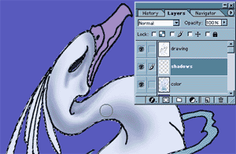 | It's good to zoom in to be able to see what you're doing. Use an airbrush to gently shade the main areas. Later, go in with a smaller airbrush and harsher colors to reenforce your shading and details.

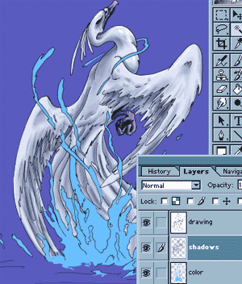 | Just keep on shading and shading. When you finish with your first color, select the second using the eyedropper tool and repeat the select/color range command. Keep shading like a madman/woman.

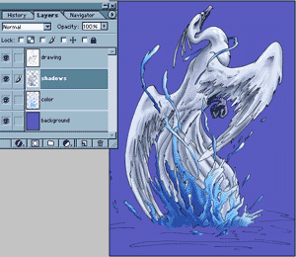 | Still shading on the shadow layer... Notice how there is a defined light source. Things to the left and bottom are darker because my lightsource shall be to the top right. Take this into account... and keep on shading! (that's the secret to nice soft style... lots and lots of detail)

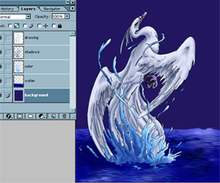 | Once you finish shading, it's time to think about the background. I created a new layer under the color, but over the background color. Airbrush in for soft edges, and paintbrush for crisp ones.  The water was done by paintbrushing in solid blue. Over the paintbrush, I airbrushed in general shapes working in more and more detail. Finally, I ran an ocean ripple, motion blue, and blur more filter on the water layer. Filters can help to enhance your work, but don't rely on them too much.

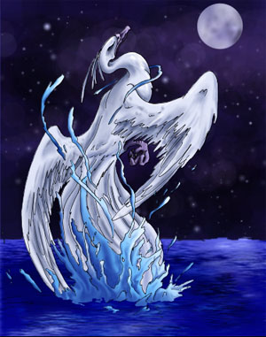 | Under the water layer I made a sky layer. Clouds done in airbrush, as were the moon and stars. Keep working that detail into your background! You want it to be as nice as the rest of your picture.

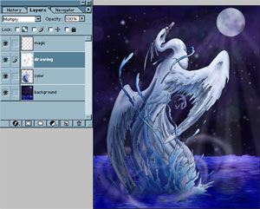 | Here's the final image. I added a last layer for magic effects. Since I am now finished with the piece, I merged the major layers to save space. You do NOT need to merge your layers, it's just what I do to preserve my harddrive. The shadow and the color were merged onto the same layer, as were all the background elements. Final layer order = magic, drawing, color, and background.

Shiny Hair
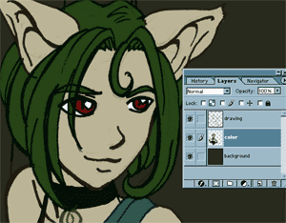 | I am often asked how I make my hair so shiny. I promply reply that I shampoo daily, but the secret is in the conditioner. *insert crickets chirping* Well, we all know that my style is very anime influenced, so of course my charcters have to have abnormally shiny hair. Here is how I create the effect.  I begin by coloring the hair in with a nice flat base color. Since anime is very wierd, you can make the hair pretty much any color of the rainbow and people will accept it as being normal; go figure.

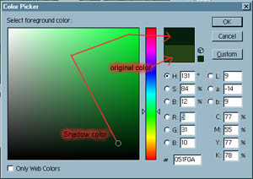 | Once I have my base color, I'm going to choose a color for the shadows. To have shiny hair, you can't just have highlights zig-zagging across the surface. You need shadows to give it depth. I choose a shadow color that's a little cooler (more blue) and a little darker then my base color.

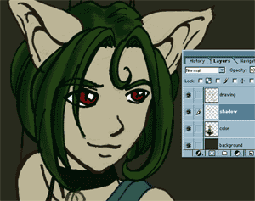 | I've decided that might light will be coming from the upper right. Because of this, the shadows will fall to the lower left of the hair forms. I use a soft airbrush and shade accordingly

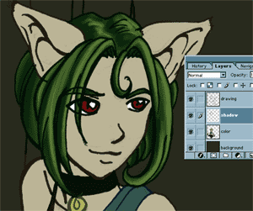 | For the lighter areas, I choose a color that's a little warmer (more yellow) and a little brighter then my base color. I shade on the upper right of all of my forms because that's where the light would hit.

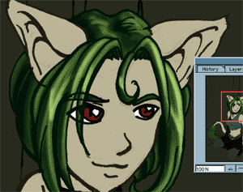 | Now I choose a color for my very bright highlights. This color is even warmer (more yellow) and lighter then any of the other colors. I highlight only the tips and the areas where the light would hit the strongest. If you follow the formula of base color / shadow / light / and highlight, your hair can be convincingly shiny :)

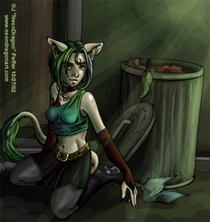 | Just in case you were wondering, here's the final image, shiney hair and all. I changed the face in the final image, because I was unhappy with the eyes, nose, and mouth.

Digital Type
Photoshop has many different options available for editing digital type. You can create some pretty spiffy effects that something like Word or Notepad would never be able to give you. This tutorial was created using Adobe Photoshop 7.0 on a mac, but it also works on PC versions 5.5 - 7.0 and you may be able to get some of the limited effects using Paint Shop Pro or Adobe Photoshop LE.
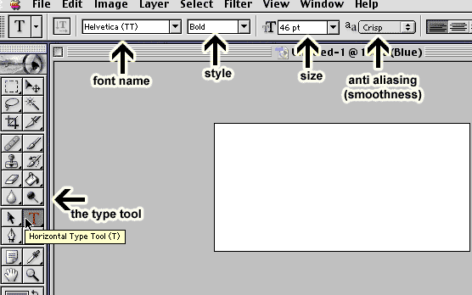
The type tool has several options available that will help you to customize your type. You can see these options by selecting the tool (the large "T") in your toolbar. The most important option is the font itself. In the diagram above, it is labeled as the font name. Clicking on it will give you a dropdown of all of the available fonts on your system. Some fonts will have a style available as well, such as bold, italic, or underlined. The size is how large (in points) the letters are. The bigger the number, the larger the font will appear on screen. Photoshop will not allow you to use decimal sizes, so make sure that your choice is always in whole numbers, If there is not the correct font size in your dropdown, you can manually type it in yourself and the size will be added. The last option is anti-aliasing. This is how smoothed out your text is. If you have no antialiasing selected your text will be pixelated. I find that the best option is "crisp" because it avoids the pixels, but does not get blurry.
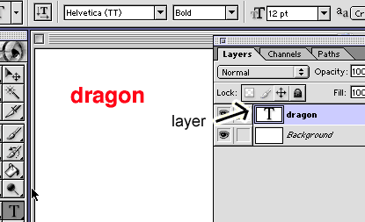
I can type in the text tool by clicking on the document with it and typing in my letters "dragon". Type creates its own layer, and this layer is special because it is vector based instead of pixel based. This means that you can resize larger or smaller without losing any resolution. It also means that text is harder to edit.
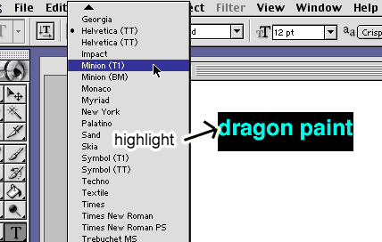
By highlighting your text with the type tool you make it active. You can then scroll through the fonts and see what they all look like if you're not familiar. ANY time you want to make a change to the type you will need to highlight the letters that you want affected.
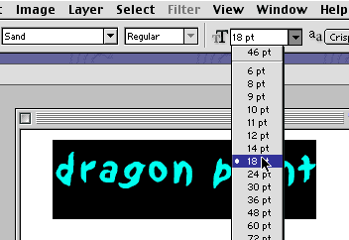
As you can see I have changed the font style and am now changing the size. I can make these changes because the text is highlighted. (I've said it twice and I put it in italics, so it must be important!)
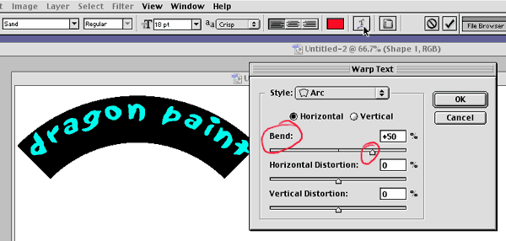
Once you have your font face and size figured out you may want to leave it at that;However, if you want your text to curve, buldge or warp in some way then you will want to use the text warping tool. Highlight the text you want to warp and click on the "T" with a curved arrow underneath it. This will bring up a menu. From there you can select what type of warp you want (style) and how extreme you want it (bend) Horizontal and vertical distortion will change the center of the warp.
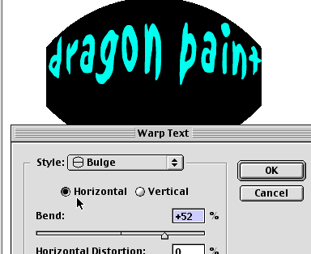
Horizontal warping warps the text widthway while the vertical selection will apply the affect heighway. Try different styles to get the effect that you want. Ready for Part 2?

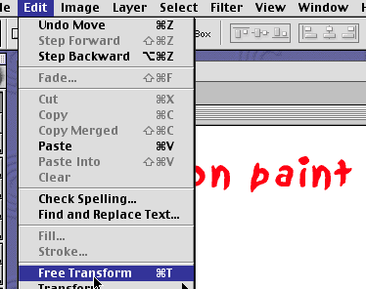
There are other ways to distort your text, the most controllable being the transform tool. You can find the transform options under the edit menu. There are two types of transformation: free transformation and regular transformation.
Free transform - You can access this through the edit menu, or by typing "ctrl+t" on a PC, or "command+t" on a mac. This tool allows you to use most of the transform functions in one step; scale, rotate, and distort.
Regular transform - this will bring up a menu of choices and will allow you to select just one aspect of the text to change.
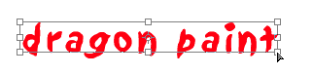
have used the free transform tool on my text layer. When active, the text will have a box around it as you see above. First I am going to scale my text. Since I have used free transform there is only one way to do this; grab a corner and pull.
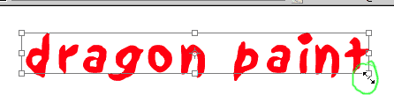
To scale in proportion, hold down shift while dragging your corner in or out. Everything will look basically the same as before, just larger or smaller. If you don't hold down shift you are able to scale the text down or up to whatever size you want horizontally or vertically. This is useful if you need the text to fit within a very specific area, but it may cause distortion that make it unreadable.
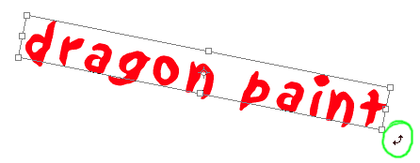
To rotate your text hover your pointer just to the outside of a corner until a bent arrow appears. Once this appears click and dragon in whatever direction you wish; the text will follow the movement. Rotate until the text is rotated to the angle that you desire. If you want your text to flip in 45 degree incriments, hold down your shift key while rotating.
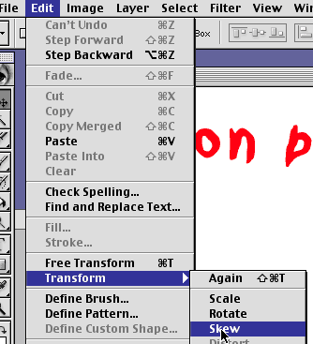
To skew your text into a perspective (useful for putting text on buildings, packages, and trucks) you can access the skew option under the edit/transform menu.
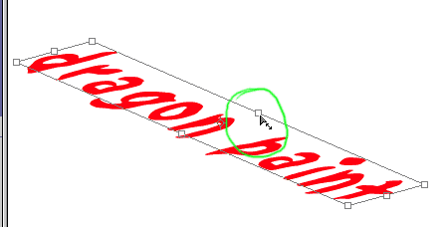
Once you have selected to skew option, click and drag on the center square in the bounding box that appears. Skew until the text works for your image.
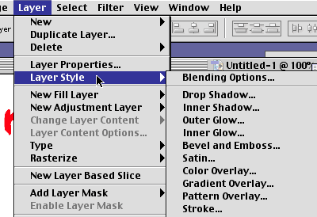
Moving on from the transform tool, layer styles are a fun way to spice up your text. Layer styles can be accessed under the layer menu. Photoshop 5.5 will have limited use of styles, while 6.0 and 7.0 will have greater options and customizability.
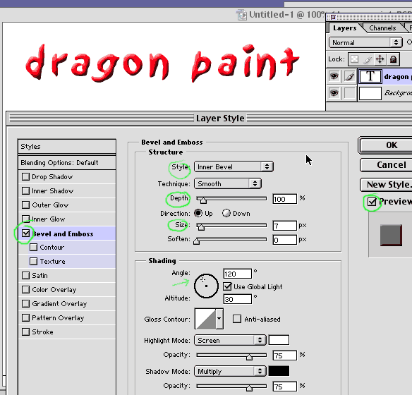
Bevel and emboss will give your text a highlight and shadow, making it look like it's 3D or sunk into a surface. Make sure that preview mode is checked so that you can see what is happening to your text as you mess with the options. The style will affect how the layer effect is applied. Depth will affect how severe the bevel is applied. Size will be the size of the highlight and shadow (larger text will require larger sizes to look 3D). Angle effects what direction the light is coming from.
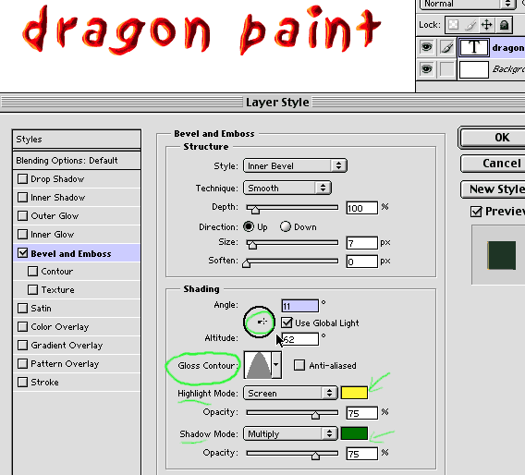
You can select what color you want the highlight and shadow to be. The default is black shadows and white highlights, but to make this fun we'll use yellow highlights and green shadows. Try ajusting the contours for different effects (It's fun to mess with! Play around!) Ready for Part 3?
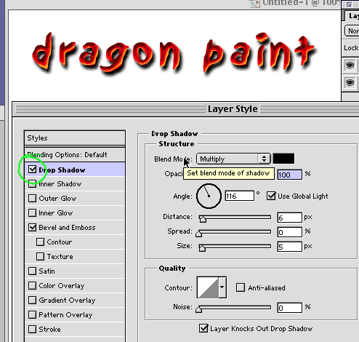
Drop Shadow is a fun layer effect that will create a shadow behind your text in the shape of your text. Having the blend mode set to multiply will have the shadow make everything darker. Having it set to screen will make the shadow lighten everything behind it (in inverse shadow). Having it set to "normal" will have the shadow be the color that is selected without any darkening or lightening; just pure color. Being able to select the color of your shadow is very useful! The angle will determine which side the shadow faces based on a light source. Opacity will control how transparent the shadow is (100% being completely solid and 0% being completely transparent).
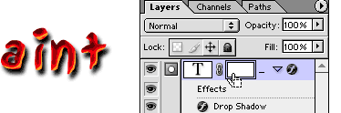
To make the text partially transparent applying a layer mask is the best way. To get a layer mask go under your layer menu at the top of Photoshop and select Layer - Add Layer Mask - Reveal All. Having the layer mask selected means that if you paint with black it will erase into the layer and painting with white will bring the color back. The nice thing about layer masks is that they are not perminate so if you don't like your effect you can discard it!
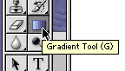
Since white reveals and black hides I'm going to select a gradient that goes from white to black. This will cause a gradual fade making the text or object look like it's fading off.
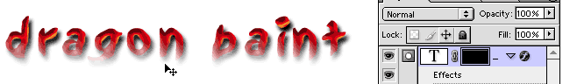
Making sure that I'm on the layer mask and not the actual picture I drag the gradient straight up, black to white. As a result where the black of the gradient was the text disappeared. These type of effects are good for if you want ghostly text or text that hides behind something else.
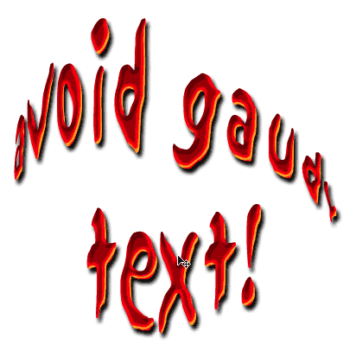
You are now ready to go into the world and cover it with interesting text! There are so many effects that you can apply to text... but you might want to consider the fact that text is supposed to be read. I've shown you A LOT of different things you can do with text. You may only want to use one or two of the effects on your type at a time. Make sure that your text is legible!

Color Shifts
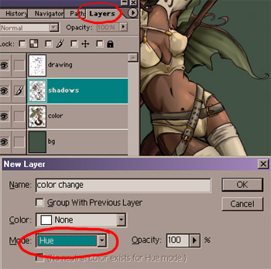 | This tutorial will cover how to do subtle color shifts. This is useful for adding some more thoughtful color selections without ruining all the shading work you put in beforehand.  After you have finished shading the object you would like to shade, create a new layer above any colors you would like to be effected.  When creating the new layer, make sure that you set the mode to "hue". This means that this layer will only effect the hue (color) of anything underneath it!

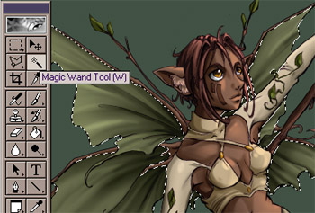 | Next select the area that you would like to be changed. I used the magic wand tool to select the wings. You can also use the lasso tool as well. Magic wand worked well for me because I had the flat green color of the wings on a seperate layer from the shading, so all it took was one click to select everything. If all your shadows and color are on the same layer, then you'll probably need to ue the lasso tool and draw around the area you want by hand. Selected areas will have a black and white moving edge around them.

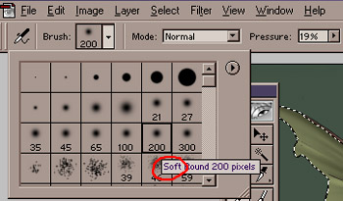 | Now choose a large, soft airbrush. This is important, because you want the color shift to be subtle. If you choose a paintbrush or a hard edged airbrush, the color shift will be extremely harsh.

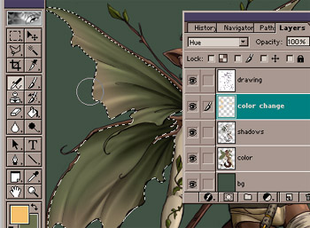 | Now run the airbrush along any area where you want the color change. Your shading and chroma brightness (how strong/gray the color is) will remain!. How cool is that? Repeat the process for any other areas where you would like a hue shift (you can put all the hue shifts on the same layer)

Cel Style Coloring
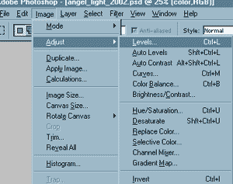 | Before you start you will need to create a clean inking on paper and scan it into photoshop at around 200 dpi. (that's the size I fine easiest to work with)  Open your document in Photoshop. We are going to start this piece by cleaning up some of the imperfections you will have when you scan things in. Even a clean inking will usually have variations in color when you scan it because of the folds and waves of the paper. Using levels will take your image, and extract only the whitest whites and the darkest darks from your image. It is under the image menu as shown.

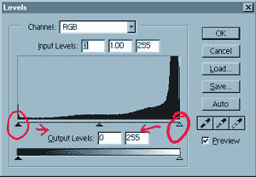 | Pull in the two arrows shown until you get an image that is clean. The arrow on the left controls your darks. Pull it in until your blacks are crisp and dark (but not pixelated!) The arrow on the right will make things whiter. Pull it in until your whites are white, but your black lines are not washed out.

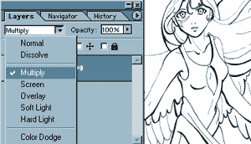 | Double click on your layer if it is named "background" with a lock by it. This will bring up the layer properties. Rename the layer drawing, inking or outline... whatever helps you to remember what that layer is. Set the layer properties to mutiply as shown.

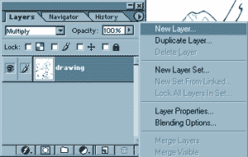 | We are now going to create a layer for the base colors of the image. You can create it by clicking on the righthand arrow and selecting the new layer option.

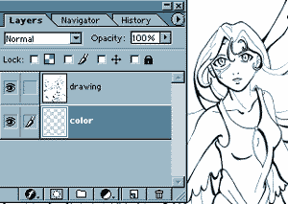 | Call the new layer "color" and drag it underneath your drawing layer.

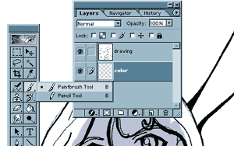 | Making sure that you are on the color layer, select the paintbrush tool. This is the tool that we will use to fill in color for this image.

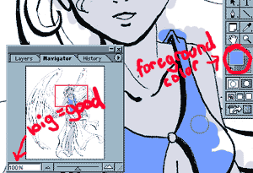 | The color you choose as your foreground color will be what the paintbrush uses. Choose a color that is dominate for each area and start coloring carefully inside of your lines. You can use a large or small brush, depending on how big the area you need to fill in is. When coloring, I like to view the image at 100% because it is easier to see if you made any mistakes.

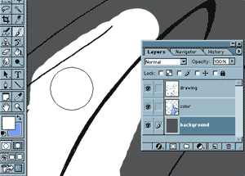 | Now I have run into a problem. I want to color my wings white, but I can't see where I am painting! (the background is white too!) To fix this, I create a new layer called background, and fill it with grey paint. (make sure to drag it underneath your drawing and color layer as shown) With this darker color behind the image, I can now see where I have painted white.

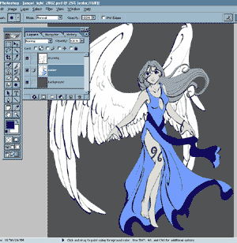 | I continue painting until I have filled in all of the areas of my character so that they stay within the lines perfectly. We are now ready to move onto phase #2...  I am so totally ready for phase #2!

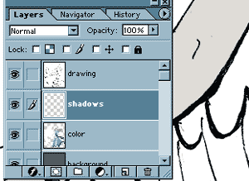 | I now create a new layer on top of the color layer, but under the drawing layer and call it "shadows". On this layer, all of our solid shadows will be placed.

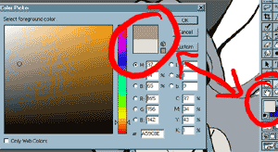 | Take a sample of the color you are going to be shading with the eyedropper tool (it looks like an eyedropper!) Then click on the color in your tool menu. You should get a chart that looks something like this. Choose a color for your shadows that is a little bit darker and a little bit richer (more to the right) of your original color. This will be what you use to shade your drawing.

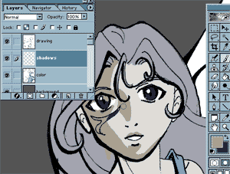 | Pick a direction where you light is coming from; you will place your shadows on the opposite side. Zoom in and use the paintbrush tool to place your shadows. If your lightsource is from your upper right, shadows will fall on the lower areas and to the left. The paintbrush tool allows you to paint in solid blocks.

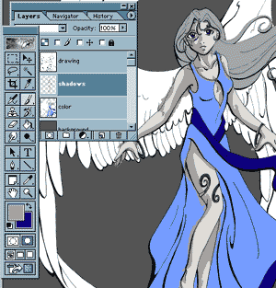 | I continue to place shadows all over her skin, which is the area I chose to work with. Don't worry if you get out of the lines! We'll clean that up in the next step.

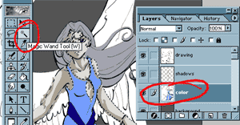 | Once you have finished putting in all of the shadows for a certain color, go to your layer labeled "color" (the first layer were you put your basic colors down) Use the magic wand to select all areas of that color. To select more then one area at a time, hold down shift on your keypad while you click.

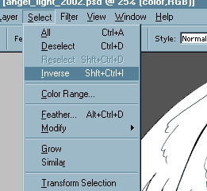 | Go back to your shadow layer. The magic wand tool should still have the areas selected. Now move up to the top menu bar in Photoshop. Choose "select - inverse" and then hit delete. You have now deleted all of the shadows that fell outside of your choosen color!

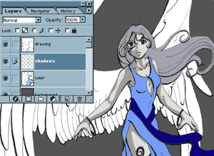 | You are now ready to do the next color's shadows. Create a second shadow layer on top of your first and repeat the process until your entire image is shaded in the "cel" style.

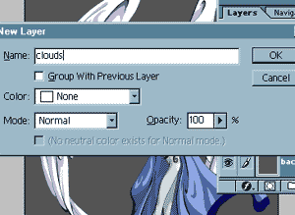 | I am now ready to work on my background. Since my character was an angel, I am going to have her float among the clouds. I create a layer at the bottom of the layer menu and call it "clouds" and paint in my background. On top of everything, I create a layer called "border" and draw in my border there. A background and a border make your piece look finished.

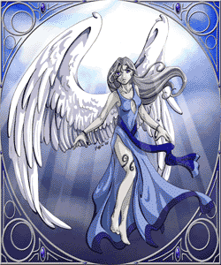 | The finished piece; give yourself a pat on the back!

Rays of Light
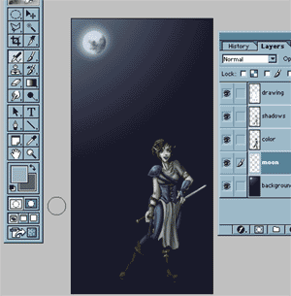 | I often get asked how I get those little beams of light in many of my pictures. Here's a little tutorial on how to quickly get pretty convincing sun or moonbeams. This tutorial was created for photoshop, but if you are using another program (with layers) you may still have some luck with it.  I have this warrior character standing against a moonlit sky. However, the moon isn't very convincing, even with the light it casts upon the sky. It's time to add some rays of light!

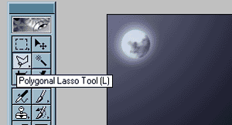 | To create a beam of light, You are going to use something called the "polygonal lasso tool". This tool is located in the toolbar. It will allow you to create shapes that have straigt edges (such as a triangular moon or sun ray)

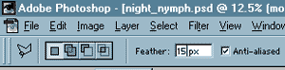 | After clicking the lasso tool, you'll want to toggle the options. If you're using a later version of photoshop, the options will appear horizontally along the top bar. If you are using an older version, you will have an options window, much like you have a layers window. By default, it will be set to give you a very hard, crisp edge. Since rays of light are less then substantial, you'll want to "feather" (fade) the edges. I usually use a setting somewhere between 10-20 pixels. The larger the feather, the more blurred the rays will be.

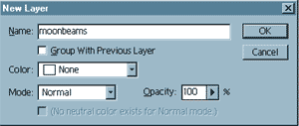 | I'm going to create a layer specifically for the moonbeams. This is important because you're going to want to erase into them later without having to worry about changing the rest of your image.

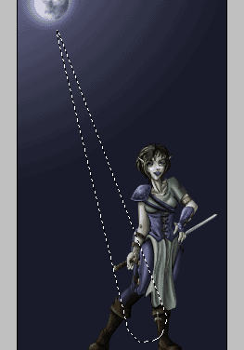 | I create triangular looking shapes radiating out from the moon. Since I have the "feather" option on, my selection will look smaller and more rounded then the actual clicks that I made; however, my selection is still large, even if the selection area appears to be small.

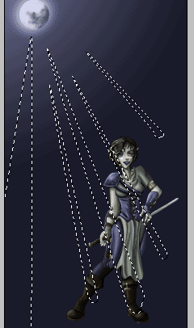 | By holding down "shift" while I use the lasso, I am able to continue to add more beams. Try not to get the beams to large, or they will not be believable.

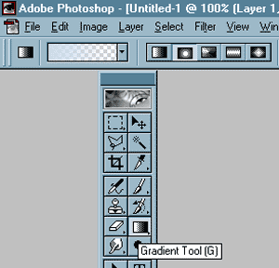 | I then select the gradient tool. I selected a light blue for my color, and I have the gradient set to fade from my foreground color (the light blue) to nothing. This will allow the rays to be brighter near their source (the moon) and fade off into nothingness. I also set the gradient to be a radial (circular) one instead of a linear one due to the fact that the moon is round, and it's light will radiate around it.

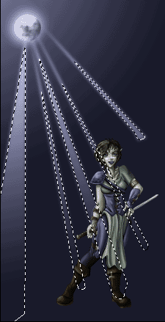 | I drag the gradient from the moon outward. The rays have now been painted. You may deselect them.

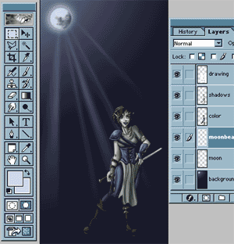 | I then go in with an airbrush eraser and start softening the rays by gently removing a good deal of the color. Soft rays are more believable then in-your-face light rays; Beams of light will only be REALLY brignt in extreme lighting conditions, such as spells, or blasts of some sort. Your rays are now complete!

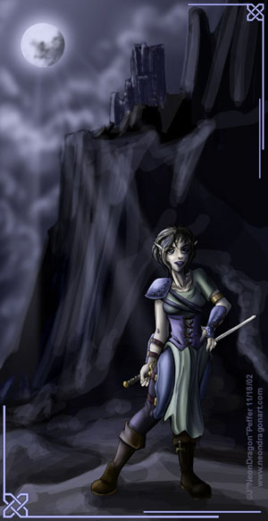 | To bring the whole image together, clouds and a background helped to make the image look finished.

Digital Comics 101
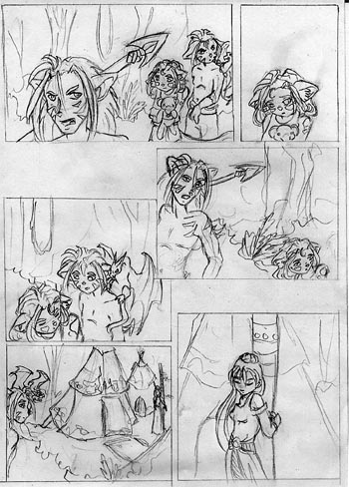 | The first step to creating a comic is pencil out the layout. Fill in the general shapes of where you would like the characters to go. Using a "dummy" as seen in the body tutorial is a quick way to get the page layed out. Once you have your drawing, use a ruler to assist you in making straight lines where the panels will go. After the panels are drawn, fill in the details and background for each of the drawings.  Things to consider:  1.Make sure there is room for text in your panels! You don't want to cover up an important part of the drawing with equally important dialogue!  2. Make sure that you have a consistent way of drawing your characters. It is odd to have a character look one way in the first panel, and in the last look like a completely different character.  3. Make sure that the reader's eyes can follow the panels in the correct order. If all else fails, use overlap or an arrow. Objects on top will be read first.

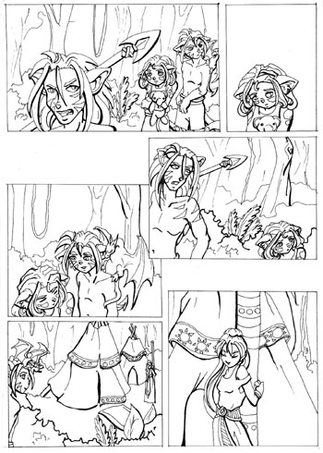 | Some digital comics color directly under the pencil work. This gives a softer, more artsy feel to the comic. Most online comics will ink their panels. Some do it in a program like Photoshop, Painter, or Illustrator, but I personally ink mine directly on the paper.  What You'll Need - A thin pen and a thick pen. I used a 005 for my thin lines, and a 01 for my thick. Microns are excellent disposable pens and come in a variety of sizes. Black gel pens or the elite rapidograph pens are also good for inking. If all else fails, grab a sharpie, but this is a worst case scenario. Sharpies will bleed so your lines will not be straight, nor will they ever get very thin. You will also need a soft, white eraser to get rid of those pencil lines.  Trace around the boxes (using your ruler... keep those lines straight!) and around all the lines of your character with your thin inking pen of choice. Once everything has been inked, wait to make sure that the ink has dried. Go in with your eraser and remove all of the pencil lines. When all of the pencil is removed, you should go in with your thick inking pen and emphasize the lower lines and the lines of things that are coming forward in space. It is very rare to make a thick line in the background.

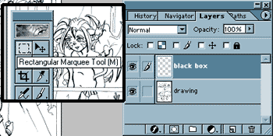 | Scan your final inking into Adobe Photoshop at 200 - 300dpi.  Open the document in Photoshop. Crop off the excess paper by useing the marquee tool to select the area you want to keep, and then pulling down the Image/Crop option in the upper menubar of Photoshop.  Adjust the brightness and contrast of your document so that you get rid of all of the extra gray. Finally, go to your layers menu and double click on the background layer, (the layer with your drawing) and rename it "drawing". Set the layer properties to "multiply" on the drawing layer. Finally, create a layer above it called "black box". We're going to box off the comic now!

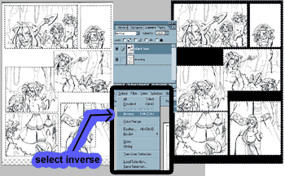 | Making sure that you have the "black box" layer active, grab the rectangular marquee tool. Click on the upper left corner and drag to the lower right on your first panel. Hold down the shift key on your keyboard and you will be able to continue to select all of your panels without losing your original selection.  Once all of the panels are selected, go to the select menu in the top menubar of Photoshop. Click Select/Inverse and the program will select the area around your boxes intead of the area inside of the boxes.  Grab a paintbucket full of black paint and dump the sucker! It will flow only in the selected area. Make sure you are on the empty "black box" layer when you do this, otherwise it will not work.

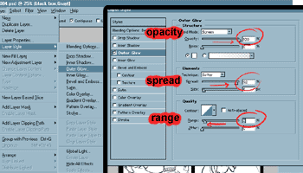 | If you would like a white border around each of your panels, follow these steps.  1. Go to the layer menu in the top menubar and select layer effects or layer style. It should bring up a box as seen to the right.  2. Change the color from the default yellow to white by clicking on the color box.  3. Drag the opacity arrow up to 100%, the spread up to 90%, and the range down to 10%. Changing the size will give you a thicker or thinner line. 5 pixels wide is the default, I usually keep it there.
At this point it is up to you to color your comic. Place the color layer under the black box layer and under the drawing layer. Tutorials on how to color in Cel Style or Soft Style can be found on the Dragon Paint site. Once all of your color is applied, it is time to move onto adding the dialogue and narritorial text to your comic.
Prepare yourself for Part #2
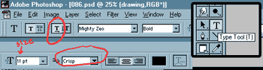 | There are two ways to do text on a comic; write it out by hand, or use digital type. Because my handwriting is sloppy, I usually use digital type. A good place to find free comic fonts is at blambot.  The type tool is in Photoshop's main toolbar; the "T" button. When you click on the T, (in photoshop 6 & 7) the top menubar will have some options pop up. Make sure that your text is set to horizontal and that your anti-aliasing is set to crisp. The menu will also allow you to control if the text is centered, aligned right, aligned left, the font style, and size of the type.

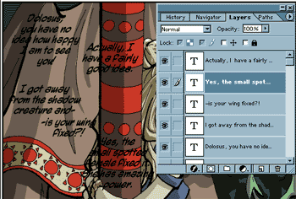 | Once you have the type set to the options you want, change your foreground color in Photoshop's main toolbar to black (or whatever color you want the type to be). In your layers menu, make sure you are above all your other layers; color, drawing, and the black boxes. Selecting the type tool again, click on your document and a blinking cursor will appear. Once this appears, start typing your dialogue on your keyboard. Hit enter for a new line. When you are done on one area of type, deselect the type tool by clicking on another tool and then select the type tool again and repeat.

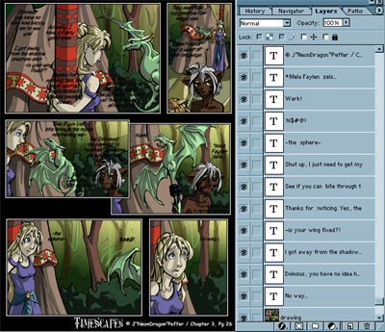 | Add text to all of the panels of your document. You can see on the how my layers were set up on the layers menu. Note that the text is on top of everything else.  I'm going to create a new layer on top of the drawing but under the text for the voice bubbles.

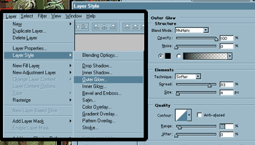 | We're going to add a layer effect to the voice bubble layer that will automatically add a black line around all of your shapes, keeping the cartoon feel.  In the top menu bar, click on layer and then click on layer effects / stroke. Place a 3-5 pixel black stroke around your boxes. Yeah, the picture shows "outer glow". That was before I got smart. Pretend the picture shows me selecting stroke like a smart artist would.

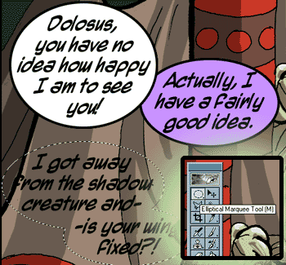 | Once again, look at Photoshop's main toolbar. We're going to use the marque tool. The default tool is usually a rectangle. Click and hold on it and you should get more options. Select the eliptical marque tool. On the bubble layer, draw an oval that is the shape of your text. If you need to move the selection, simply click on the center and drag it. You can do multiple selections at a time by holding "shift" on your keyboard.  Once your bubble is selected, click on the paint bucket and fill it with whatever color paint you want. The paint will flow inside the area of the selection, and your layer effects will automatically add a black border.  If you use the polygonal lasso tool, you can add triangles that lead to the mouths of your character, completeing the bubble so that it's not just a circle.

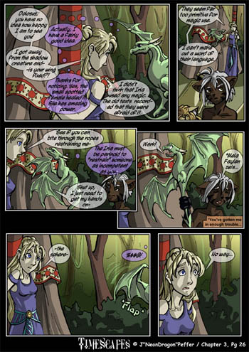 | Once you are finished, you are ready to save your file as a jpg, viewable online. Your file will probably be very large, so you will need to scale it down. Click "Image" in the menu and select "image size". Making sure that constrain proportions is checked, type in new pixel values for how tall or wide your image is. Constrain proportions will make sure that it does not morph. Once the image is scaled down to a viewable size (mine are usually 700 pixels tall) save it as a jpg by clicking "save a copy" in the file menu and selecting jpg as the file type.  Your online comic is now ready to be viewed by the world!  If you do not have your own homepage, I recommend getting a free account with keenspace or drunk duck, two online comic hosting sites.

Rain Effects
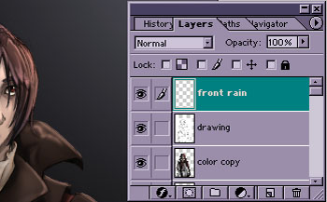 | Here is a quick, relativly painless way to get good looking rain in Photoshop. This tutorial may work in other programs such as GIMP or PSP, but you'll need to modify the commands accordingly to the setup you're working with.  Begin by creating a new layer for your rain to go on. You do not want to work on the same layer that you have any of your linework or colors on because we are going to apply an effect later in this tutorial that we want to effect the rain only. Having the rain created on its own layer allows us to do this easily.

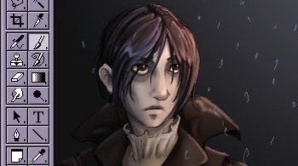 | Take a small paint brush and begin placing dots or small scratches all along your image. Make sure that you are using a paintbrush or airbrush with opacity turned to 100%. You want these marks to be VERY visible. Don't worry if it looks silly.

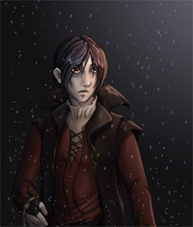 | Continue placing marks all over your image. The more marks you make, the greater the downpour will appear later. If you want a light rain, keep them fairly far apart from eachother.

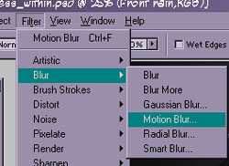 | We are now going to use a filter to give the rain the appearance of motion. Right now it kinda looks like snow! To do this, we will use a motion blur. You can find it under the filter menu up top under the blur subcategory.

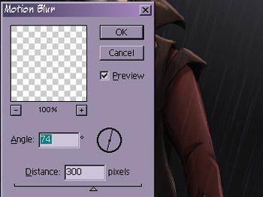 | When you select motion blur, a little popup box should appear that looks something like this. The angle will allow you to control the direction the raindrops are blurred and stretched, and thus the angle of the rain itself! The distance controls over how many pixels the blur is applied. For faster looking raindrops, make the number greater.

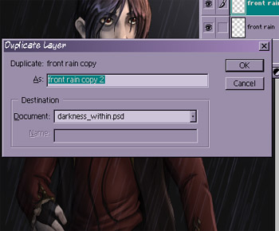 | After the effect has been applied your rain will end up looking very transparent; it's no wonder! You did take just that little bit of "paint" and stretch it over a great distance! Duplicate your rain layer to make the streaks a little bit more noticible. You can duplicate it again and drag the new layer to your background and move it around to create even more layers of rain beyond.

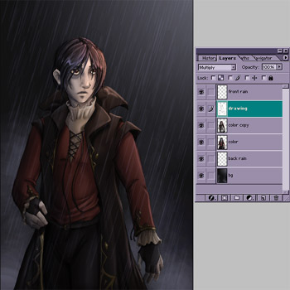 | Now that we have our "rain" it's time to make it look convincing. In my image, I chose to employ some mist and the starts of light and dark where clouds will be in the background. Rain is rarely without clouds or humidity, so if you're noticing that you want a little bit more of a realistic effect, this is a good place to start!

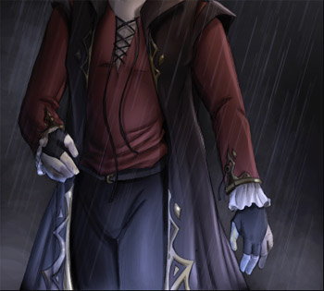 | Since it is night time, I'm going to make the rain a thunderstorm. There's a lot of water on the ground, yes? Thus it will reflect the lightning I'm going to create and will create a cool light source below my character. I begin adding blues and some highlights to bring this out for my particular lighting situation.

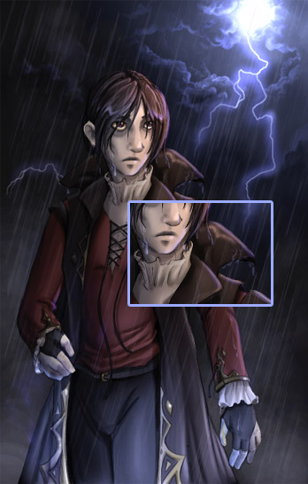 | Finally I finish off the sky by creating clouds and lightning. I make the character look wet by going in with an airbrush and putting individual drips of rain on the guy to make him look convincingly soaked. It's little details like heavy, droopy hair, drips, and rivers of water going down your character that will bring everything together. Enjoy soaking your models!

