The Dragon Tutorial
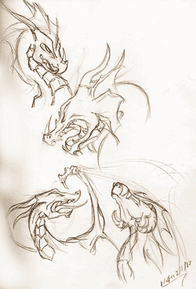 | Updated for 2003, the Dragon tutorial continues to grow. This tutorial mainly focuses on the head, basic positioning, and on things like horns, tails, and frills. Check out the claw and wing tutorials for help on those specific parts.  There are so many different ways to approach the dragon head. This tutorial is going to show how to do a basic side and 3/4 view of the dragon head. What makes every dragon unique is the horns, frills, ears, and other little touches. Make a dragon all your own!

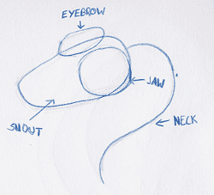 | We're going to build the dragon head with 4 basic parts; the cheek/jaw, the eyeridge, the snout, and the neck. Start by bubbling in these basic shapes for a side view, the easiest view to pull off.

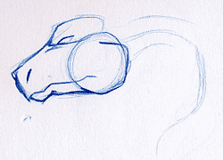 | Building on top of the shapes I fill in the lower jaw and split the mouth open with a beak-like finish. I add in an eye, build up the eyeridge, and add a nostril so that our little dragon can breath!

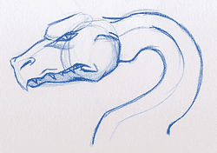 | Now I start going in for more details. I give the eye a pupil and sink it farther into the head. I add an extra flap of skin around the nose and the end of the mouth to give it a 3-dimensional look. Teeth can be shown coming over the lower lip or they can be hidden until the dragon actually opens it's mouth; it's a personal choice, I designed this dragon with the teeth overlapping.  Fleshing out the neck is a good idea before you finish off the head so that the connection to it does not look awkward.

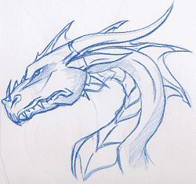 | Finally we add in all of the little details that make the dragon unique; a crest along the back, several horns, and a plated belly.

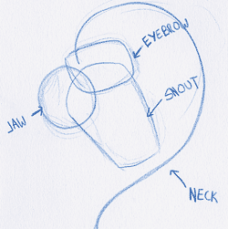 | Now that we've mastered the side view we shall try a 3/4 view of a dragon curling it's head around. Start with the same bubbles (the structure of the head does not change!)

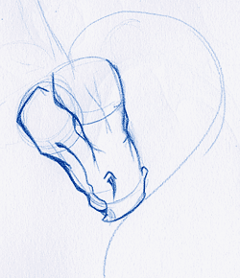 | Once again we fill out the form of the dragon by giving it a lower jaw and splitting it's mouth open. The eye, a defined eyeridge and nostril are added.

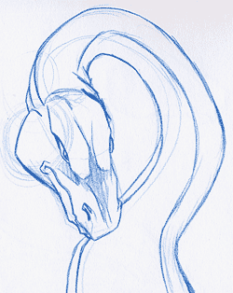 | The neck is built up and the face takes on a more definate form with the addition of a pupil, skin flaps, and by sinking the eye into the skull.

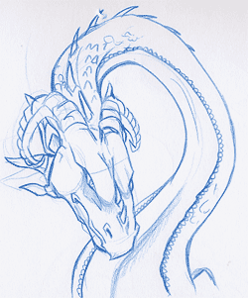 | Last come the details (you'll notice a pattern!). This dragon has curling rams horns, 2 ears, and scales running along the ridge of the belly. Isn't he absolutely adorable? Don't you just want to hug him and squeeze him and take him home with you? No? Ok, never mind.... onto the next section...

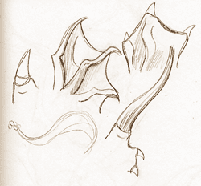 | There are many little attachements that you can add to your dragon to make it more unique. Horns, frills, hair, scales, ears, nails; all of these are things that you should be thinking about.

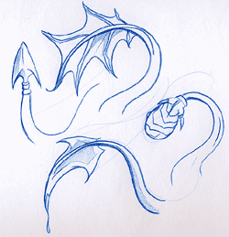 | Tails adornments are a fun way to give your dragon a little flair. Fins, clubs, and spikes are adorable and o-so-stylish!

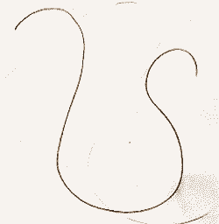 | Doing a full bodied dragon is easiest if you start simple. I usually start my dragons with a line of motion. From this serpentine line you can build your dragon.

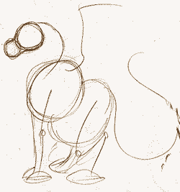 | Start simple. Put in some basic shapes for the chest, hips, and head. Lines can be used to show where legs, tail, neck, and wings will go. For more information on how to draw wings, check out the skin based wings tutorial.

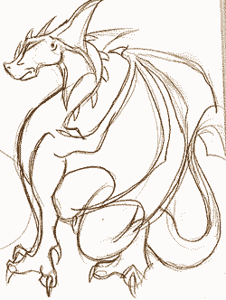 | Last comes all of the little details. Flesh out the lines that you drew for legs. You can base your body and legs of the dragon off of big cats, lizards, or birds of prey. Get refrences of these to help you learn how to draw the parts. The claw tutorial may be useful.

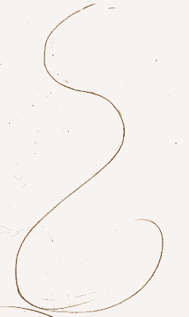 | Another start of a dragon. Notice how I always start with a line of motion. It keeps your dragon from bouncing all over the page in an unnatural manner.

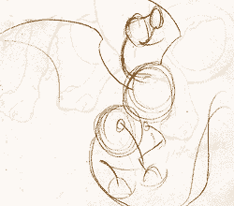 | I fill in the dragon "skeleton". This dragon does not have any arms, but instead has wings located where the arm joints would be. Put in all of the bends for your legs.

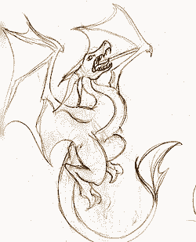 | ...and now we fill in the details. Mr. Dragon is so happy that he is in proportion. Don't let these tutorial restrict you! If you use the same basic line of motion you can put your dragon into whatever position you can dream up!

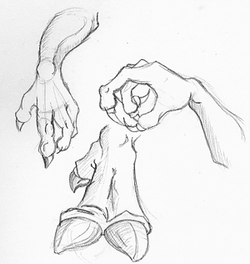 | Claws can be short and nail-like, such as the nails that you would see on a dog. Claws can also be retractable, such as you would see on a cat. They can be long, like on a bird of prey, or hoof-like. Find a type of claw that goes with your creature.  Here are some examples of finished claws. The top left would only be useful on a creature that walked on two legs, the claw you see being an arm and not a leg. The one to the right would be useful on something that flies. The lower one would be a back claw, something meant to bear weight.

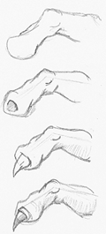 | People will often draw a hand, and then draw a little triangle coming off of the end of it for a claw. This is not a good way to do it, because claws do not grow this way.  1. Here is a digit without the nail.  2. The nail comes out of the center of the digit. The shaded area shows where it grows out of.  3. I place the nail coming out of the center.  4. I place a cuticle so that there is a small area of skin growing out with the nail. It's a nice added effect.

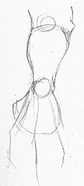 | I'm going to show an example of how I draw a clawed hand from start to finish. In this stage, I have just the basics of the forearm, the wrist, and where I want the fingers to go.

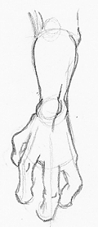 | I fill in the fingers. Adding large bumpy knuckles helps to make the drawing less hand-like and more claw-like.

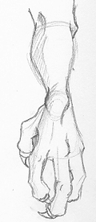 | I grow the nails out of the center of each digit. Since all of the digits are at different angles, all of the claws will be bent at different angles. As long as you draw them coming out of the center of it's respective digit, the claw will make sense. Happy drawing!

Gryphons
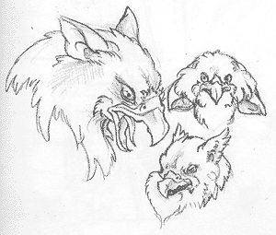 | Here are some basics on the wonderful beasties known as Gryphons, Griffons, or Gryffons. Gryphons are creatures of myth, a cross between a raptor and a large cat. For specific "breeds" of gryphon, get photo refrences of the bird and the cat that you would like to cross. Please check out the wing and claw tutorials for the other body parts.  Aren't they adorable. Gryphons can come in many shapes and sizes. Because they are creatures of myth, there is no "right" way to do them. However most gryphons will have a raptor head, with ears/eartufts, and a sharp beak.

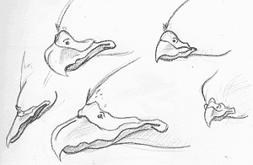 | There are many different shapes of beak. Please note that there are 3 parts to each beak; The lower Jaw, the upper jaw, and the nostril area. You can use an eagle, hawk, falcon, crow, or owl beak and each will still have the same basic parts.

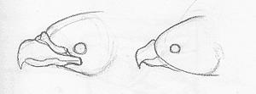 | Please note that the beak will always go BACK into the face (left). Sticking it right onto the face (right) looks awkward. Always take your beak back into the head so your gyphon can open it's beak.

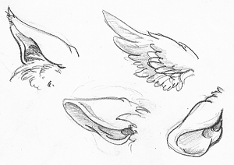 | Ears can be done many different ways. They can be simple featherd tufts, or the ears of a draconic or feline creature. Ears can pivot, or remain stationary.

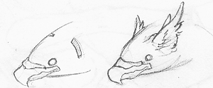 | The ears would probably go just behind the eyes near the back of the skull. This is just a guess, since the creatures aren't real and I have nothing to compare to, but I find that putting them in this location looks best.

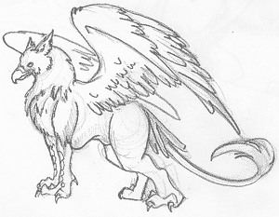 | Last, but not least, a full picture of a gryphon. The front claws are usually those of a bird of prey, while the back are usually the paws of a cat. You can do a double tail (feathers and cat-tail) or one or the other. I hope that this tutorial was helpful in some way.

Leather Wings
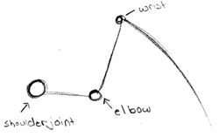 | First we start out with the basic skeleton of a wing. Notice how simple it is. It can be bent at several different angles and rotated in space for different postions.

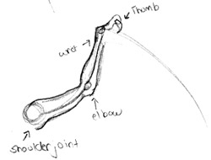 | After drawing the skeleton, add some muscle to the "arm". There will be more muscle where the wing connects to the body because this would be the area that does the most work if your creature would actually be in flight ^_~ A "thumb" may also be added, but this is not nessesary; you could do a spike, a double thumb, or any variety of things!

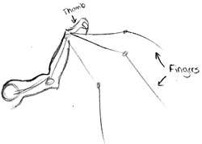 | Next sketch out where the "fingers" of the wing will be. There can be as little as one finger, or as many as 20, perhaps. It all depends on how you want your wing to look. Typically, the more fingers there are, the less muscle each of them will have. Remember that most fingers have to bend at some point. For a more complex wing, a knuckle joint will always help to give structure.

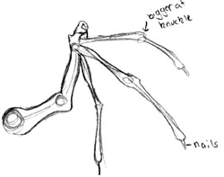 | Now it's time to add flesh to your fingers. They can be as thick of as skeletal as you desire. Near the knuckle joint, there will typically be a widening because two bones are meeting and need room to move past eachother.

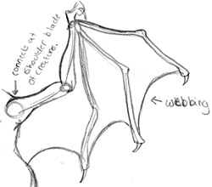 | What you have now are really enlongated hands. To turn these guys into wings, there will be a skin membrane stretching between each of the digits like webbing. The curve of the webbing can be as rounded and severe as you like.

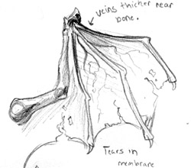 | Here are some tiny additions you can add to your wing. For a more rugged look, you can add tears where your creature has gotten into a fight or two. If you want your creature in top condition, then don't add them. Veins will show where blood flows. It's all a matter of what you think would look best for you!

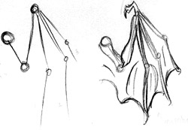 | The skeleton of the wing can stetch out very far, or it can fold up. Here is in example of how you could go about doing a loosely folded wing. Notice how you have slack membrane in between the fingers.

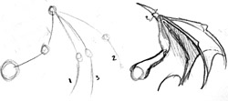 | Wings can also curve around in space. When building this skeleton, I put the last digit (3) in front of the other two. When webbing and shading are added, the wing makes sense again.

Feathered Wings
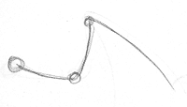 | First we start out with the basic skeleton of a wing. Notice how simple it is (it is also idential for that of skin based wings!) This simple skeleton will help you to position the wing.

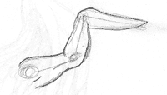 | Just to give you an idea of how a real wing works, look at where the muscle would probably go. The feathers grow off of this powerful area of muscle. Gah! That looks like something that I ate for dinner!

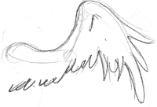 | On top of the muscle, add layer one of feathers. The side closest to the shoulder will have shorter, even feathers. Near the bend, the feathers get a little longer.

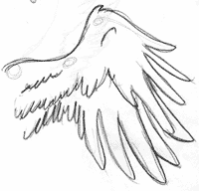 | Now underneath the first layer of feathers, we add a second. Notice how long the feathers get near the edge.

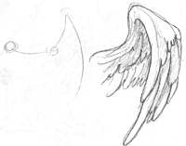 | Here's an example of a curving pose for a wing. See how the skeleton helps you with the pose?

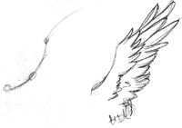 | An example of a wing unfurled. Once again, a skeleton was used to assist with the structure.

Fairy Wings
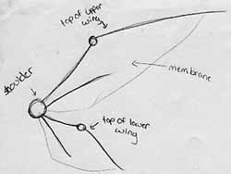 | There are many different ways to do fairy wings. Some do small webbed things, some draw insect wings, and some draw buttefly wings. Each of these areas has a hundred different ways to create the wing, but if you're curious about my particular way of doing fairy wings, here it is.  My fairy wings have 2 seperate parts. Please note that the upper section is larger and the wings have an area of bone and an area of membrane.

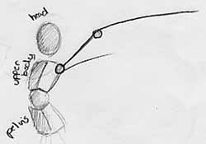 | Wings will usually connect at shoulder blade in the upper half of the torso. Start off by drawing a line with an angle in it. This line will eventually become the bone, which needs an "elbow" to bend when the fairy flys. You can add a second, smaller bone to make your wing look like it has more support.

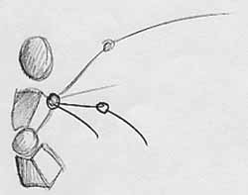 | Draw another, smaller, bent line that connects to the back just below the first one. This will form the second part of the wing.

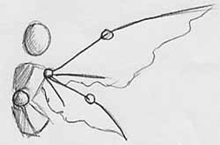 | Now add the membrane, For a delicate looking membrane, create a squiggly line to hint at a brittle, shaped wing. For a tougher membrane, make the line smooth and it will look like the skin is streached taunt.

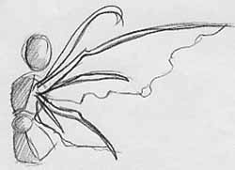 | It is time to fill out the bones so they have a definate shape. The "elbow" may be a little larger and have a bump on it to make it look like a joint, where two bones connect. I like to add little wispy bones at the top which are decorative and have no function.

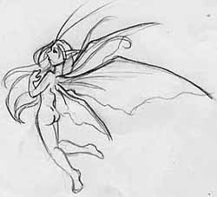 | The wings are complete you are ready to move onto other things. Your fairy now take flight!

